First Annual “Three Amigos Ride”

Start – Torrance, CA to Carlsbad, CA – 108 miles October 7th 2005

Uneventful ride from one Amigos house to another Amigos house!

Day 1 Carlsbad, CA to Tucson, AZ via Yuma, Gila Bend, Ajo & Why – 524 miles

This was a long ride. We left Carlsbad, CA at about 4:30 AM and rode to El Cajon, CA where we had a nice breakfast. Back on the bikes to I-8 and on to Gila Bend, AZ with a gas stop just before Yuma, AZ. We fueled up at Gila Bend, AZ and turned south to Tucson via the interesting and historic town of Ajo. About 5 miles out of town, as I was enjoying the music from the Harley stereo, the cassette tape ejected. I reached up to pull the tape out and ended up with about 20 feet of tape trailing the motorcycle at about 70 mph. The tape player ate the tape and jammed. Oh well, tune to the AM station with plenty of music from Mexico. At the small town of Why, AZ, about 50 miles North of the Mexican Border, we turned east towards Tucson through the Tohono O’odham Indian Reservation. The scenery was pretty with the temperature just above 100 degrees. We arrived tired at our nephew’s house at about 3PM where we met up with the 3rd Amigo.

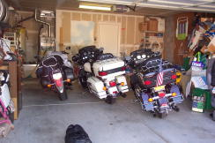

Day 2 Tucson, AZ to Silver City, NM via Tombstone, Bisbee, Douglas & Lordsburg 295 miles

We enjoyed great hospitality and a nice BBQ dinner with family. We awoke before dawn to a cool, clear Arizona morning and mounted our rides to get out of town before the working folks jammed the roads. Heading south we stopped at a nice country café in Benson, AZ for breakfast. On to the famous OK Corral in Tombstone, AZ where we arrived about 7:30AM. One area of the main street was blocked off and populated with awesome Chevrolet corvettes from all over the Southwest. The rest of the town was very quiet. We spent time wandering around absorbing the history of this place that played a part in settling our Southwest Territory. We departed Tombstone bound for Bisbee, AZ. What a wondrous site as we approached Bisbee. We were winding through the foothills when the town was spotted down in a lovely canyon. We proceeded down the canyon and entered the town. Old historic buildings placed side by side all the way up the curving canyon. All of the Amigos enjoyed our time in Bisbee. Off to Douglas, AZ, a town that is situated on the US/Mexico border. As we approached Douglas we noticed large thunderheads just to the South of us and a few sprinkles of rain. We put on what rain gear we had and got the heck out of Dodge – er Douglas. Thunder clouds in front of us, behind us, to the right of us and to the left of us. We rode past pools of water, encountered a few showers and made it to Silver City, NM – with a stop in Lordsburg – without encountering a major downpour. Aw, Silver City, with plenty of motels. What! All full – No rooms available. Thunder cells to the right of us, thunder cells to the left of us, thunder cells in front of us, thunder cells behind us, what do we Amigo’s do? Well, we send the oldest Amigo into the Super 8 Motel on a mission of mercy to get us some shelter. Out comes the senior Amigo with a smile and a room key. Oh yes, it is a room

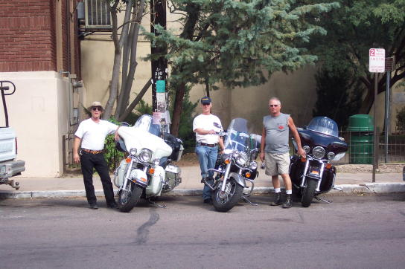

That is in the process of being renovated, has no flooring in the bathroom and is generally a mess, but is sufficient shelter from the approaching storm. We procured a rollaway bed, sufficient linens and towels and walked to dinner after securing and covering our motorcycles. The storm was a gulley washer and lasted nearly the entire night. Mr. senior Amigo assured us that it would be clear and beautiful in the morning.

Day 3 Silver City, NM to Payson, AZ via Alpine, Springerville, Show Low, Salt River Canyon, Globe & Roosevelt Lake – 352 Miles

Well it was a beautiful morning, but not clear. We dried our bikes and rode to Grandma’s Café for a home cooked breakfast. We again seemed to be riding in the eye of the storms and avoiding any rain. As we approached Alpine we were introduced to the rare experience of riding a motorcycle in a hailstorm.
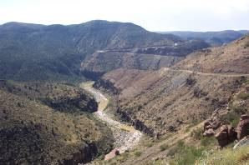

This was beautiful country, but we missed some of the scenery as we concentrated on staying upright and focused. We entered the awesome meadow where Alpine; AZ is situated, with the storm forever behind us. Through Springerville and Show Low to the magnificent Salt River Canyon.

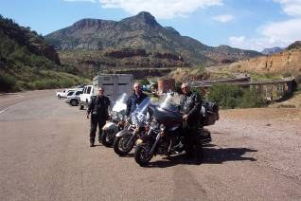

We followed the canyon to Globe, AZ. Up through the Roosevelt Lakes to Payson, AZ. After dinner and a walk to the Dairy Queen we retired for the night.
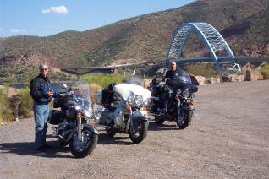

This would be the end of the Three Amigo’s Ride as the Junior Amigo had a limited ‘Kitchen Pass’ and would depart for home sometime in the middle of the night.

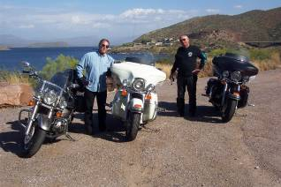

Day 4 Payson, AZ to Wilcox, AZ via Roosevelt Lakes, Globe, Safford & Chiricahua National Monument – 289

The Two Amigo’s left Payson in the morning returning to Roosevelt Lakes and Globe. We headed out of Globe to Safford, AZ and on to Wilcox, AZ. At Wilcox we were surrounded by 100 Maricopa County Sheriff Deputies and their vehicles returning from

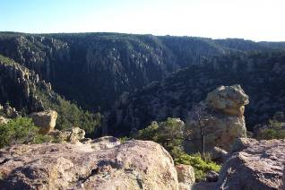

Their second mission of Mercy to New Orleans and the Gulf after hurricanes Katrina and Wilma. After arriving in Wilcox we decided to take a side trip to the Chiricahaua National Monument, which is about 46 miles Southeast of Wilcox. We arrived about fifteen minutes before the visitor’s center closed. After an introduction from the ranger we took a ride through the monument. This area is quite spectacular and well worth the visit.
http://www.desertusa.com/chi/
We headed back to Wilcox for the night after a relaxing days ride.

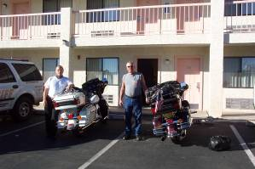

Day 4 Wilcox, AZ to Truth or Consequences, NM via Steins NM, Animas NM, Hachita NM, Columbus NM, Deming, NM & Hillsboro, NM – 317 miles

We departed Wilcox in the morning heading East on I10. We decided to stop at the old mining and railroad town of Steins, NM. The time advanced one hour as we crossed the New Mexico border so we arrived at Steins just as the quaint store was opening. Steins was purchased from the railroad a few years ago by a retired couple. There is still much left of this historic town. During the days of the steam engines the railroad would tanker water here to service the steam engines. When the diesel locomotives arrived the town died.
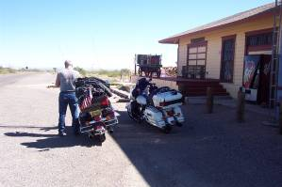
A few miles past Steins we turned south towards Animas and the Mexican border. At Animas we turned East heading through miles of pleasant desert occasionally being stopped at Border Patrol checkpoints. The area between Animas, NM and Columbus, NM is horse and cattle country. The Old West still exists in this part of the world. We arrived at Columbus, NM at lunchtime. Which, by the way, is anytime we decide to have lunch! Columbus, NM is about three miles North of the border with Mexico and was a staging point for General ‘Blackjack’ Pershing as he pursued Poncho Villa. Our first stop was a visit to the local museum. The museum is full of artifacts and does a good job of representing the history of this region. We had a nice visit with the docent. We had lunch at a small café next to the one police officer, one police car, police station. We headed North from Columbus, NM towards Deming, NM through miles and miles of red chili pepper fields. We arrived in Hillsboro late in the afternoon and decided not to attempt the fifty miles of winding road over Emory Pass so we continued North to Truth or Consequences, NM for the night. After doing some laundry, happy hour, a Jacuzzi and a nice dinner we retired for the night.

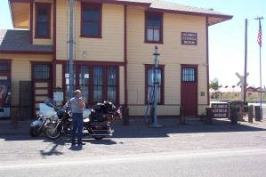

Day 5 Truth or Consequences, NM to Wickenburg, AZ via Emory Pass, Silver City, Lordsburg, Wilcox, Benson & Tucson – 477

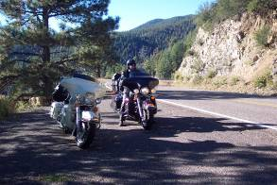

We wakened to a beautiful morning, had a nice breakfast and departed Truth or Consequences heading for Silver City and the mountain pines and curves of Emory Pass. This was a great ride across the mountain. Cool fresh air and the clean smell of pine as we motored past rock formations and tall pines. We eased ourselves around the 50 miles
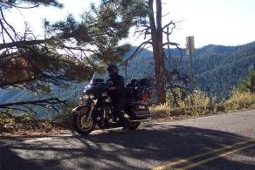
Of ‘S’ curves as we climbed the mountain and then descended into the valley and the huge mines of Silver City. We fueled the bikes and headed Southwest to join Interstate 10 and an uneventful ride to Phoenix, AZ. Oh my, back into civilization and the detours, slow bumper to bumper traffic and heat radiating off of the Harleys as we navigated through suburbia to route 60 and on to Wickenburg. Arriving in Wickenburg we elected to stay overnight in the center of this old western town at one of the original Best Western Motor Hotels. We enjoyed happy hour and a nice dinner and put our weary but happy bodies to bed.

Day 6 Wickenburg, AZ to Torrance, CA via Wenden, Quartzsite & Blythe – 351 Miles

Up before daylight we walked in the cool desert air to a local café for breakfast and a nice visit with some of the early riser locals. We fueled our bikes and bid each other good-by as the oldest Amigo headed for Gallup, NM and I headed home to Torrance.

The Three Amigos hope to ride again soon. But first we will celebrate the youngest Amigo’s 60th birthday!!!

