Friday June 1st 2007

Costa Mesa, California to Peach Springs, Arizona – 384 miles

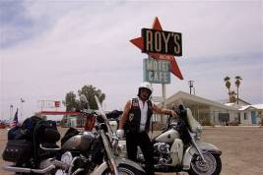
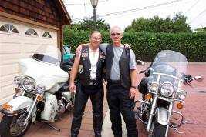
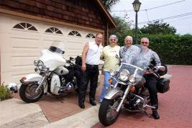
On Friday June 1st 2007 Joe (Amigo #2 riding a 2002 Harley Davidson) met Rob (Amigo #3 riding a 2002 Yamaha V-Star 1100) at their cousins, Tom & Nancy at Costa Mesa, CA. Joe& Rob departed at approximately 11AM on the first leg of the 3rd annual 3 Amigos ride. The ride took us on the 55 freeway to the 91 freeway toll road (Joe had 2 transponders so motorcycles are free) to I10 to Hwy 62 and on to Twenty-nine Palms, California for fuel. We had a nice cloud cover as we rode to Amboy and Route 66. We stopped at the famous Roy’s Café (now closed) in Amboy for photos. Continued on Route 66 to Mountain Pass where we intersected with I40 thru Needles, California across the Colorado River into Arizona and a stop at the intersection of I40 and Arizona Hwy 95 for fuel and a cool drink. Rob went on reserve fuel about 15 miles before we stopped. Temperature at this stop was 111F. On to Kingman, Arizona where we exited I40 at Old Route 66 to top off our fuel tanks and take a short break. Since neither of us had been on this road we felt that a full tank was the best way to proceed. Traveling on through beautiful country Joe ran over a rattlesnake. The town of Peach Springs is a small oasis and quite pretty.
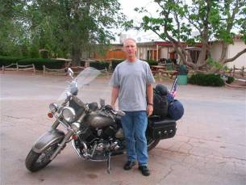
We stopped at the Grand Canyon Caverns Inn, about ten miles past Peach Springs for the night. Our room was clean and nice with air conditioning. However, one of the lamps was missing the
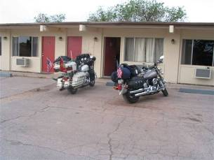

light bulb, the phone did not work and Joe twisted the switch off of the lamp that did work. We went to the office for a light bulb. No luck. We mentioned that the phone did not work and were told that we could go down the road a couple of miles where our cell phones would work. Choosing not to use that option they offered to let us use the office phone and our phone cards, which we did. What a hoot. That completed we rode our bikes to the Caverns Café located on the property about a mile from the motel. The food was good and our server, Jennifer, was a good sport. Back at the hotel we went to the patio, had a cool drink and enjoyed the live music. Back at our room we watched part of a movie and off to bed early.
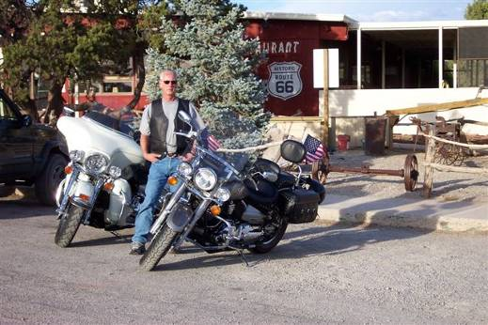
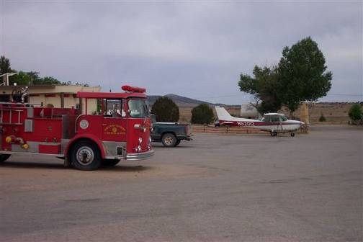
Saturday June 2nd 2007

Peach Springs, Arizona to Gallup, New Mexico – 252 miles

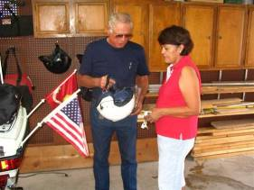
We awoke to a beautiful high desert morning. Coffee was available in the lobby about 6:30AM. After coffee and breakfast bars we cleaned the bikes and prepared for another days ride. The morning air felt clean and crisp as we headed off on Old Route 66. We intersected I40/66 at Seligman, Arizona and continued on I40/66 to Williams, Arizona where we stopped for fuel. Williams is the gateway to the South Rim of the Grand Canyon and the Southern terminus of the Grand Canyon Railroad. At the suggestion of the gas station attendant we proceeded into town for breakfast at ‘Old Smokey’s’ café. The food was great at this family run café. The son of the owners was admiring Rob’s bike as he had a similar model. This would lead to some nice conversation with him and his fiancé. His future in-laws have a place on the Colorado River very close to Joe & Claire’s place. What a small world we live in. After breakfast we rode I40 to Holbrook, Arizona where we stopped for fuel. We called Mike (Amigo #1 riding a 2005 Harley Davidson) to let him know that we were about an hour and a half from his home. Back on I40/66 we rode to Lupton, Arizona where Mike met us at the ‘Smoke shop’. The 3 Amigos then rode across the border into New Mexico where Rob topped off his fuel tank and on to Mike’s house at Gallup, New Mexico. After cleaning the bikes and performing a little maintenance we enjoyed a BBQ and wonderful family time. Mike and Marie had prepared their travel trailer as a Casitas and Rob and Joe retired to a sleep complete with train whistles all night long. I guess that you get used to it after a few years!

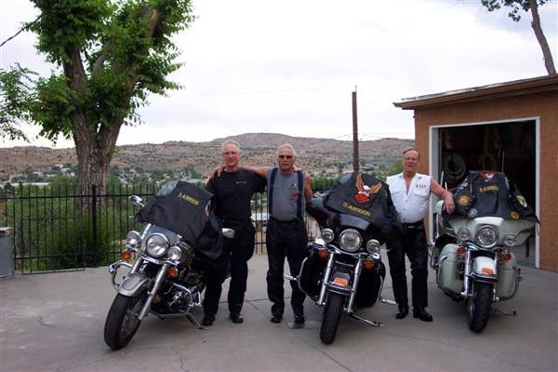

Sunday June 3rd 2007

Gallup, New Mexico to Farmington, New Mexico - 297 Miles

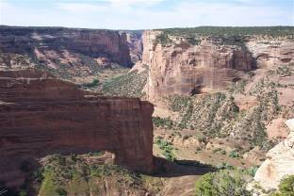
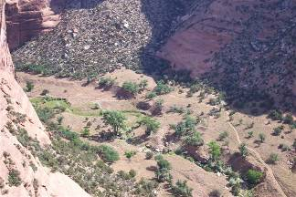
We awoke early to the sound of the trains. Gallup has over one hundred trains a day. I think that we heard every one of them. Mike prepared a very nice breakfast for us as we prepared for our days ride. We took some photos of the bikes and were then off to experience the Navajo Indian Reservation. We left at about 7:30AM and rode North on 491 to Sheep Springs, West on 134, North on 12 and then West on 64 to the North Rim of Canyon de Chelly National Monument. We stopped at the Massacre Canyon overlook to view this magnificent canyon, learn some history and take some photos. On to the South
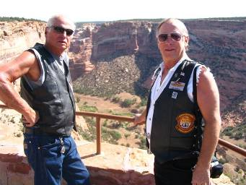
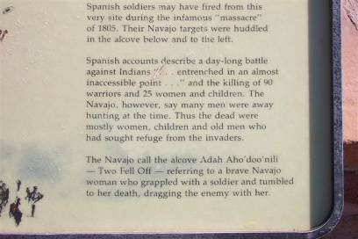

Rim where we stopped at ‘Spider Rock’ and ‘The Whitehouse’ overlooks.
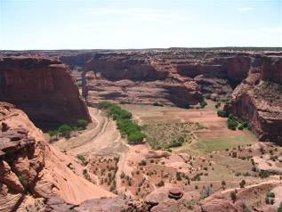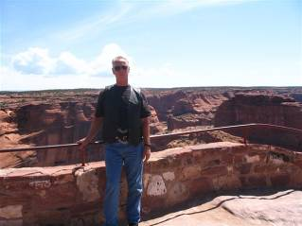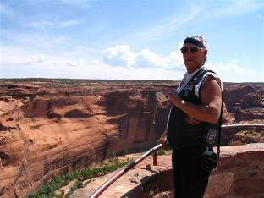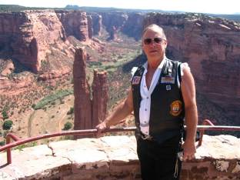
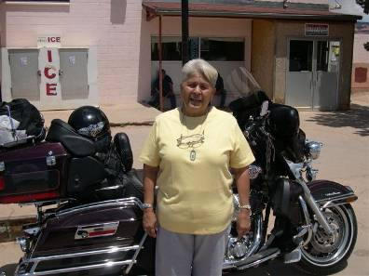
The beauty and spiritual significance of Canyon de Chelly is almost beyond my descriptive capability. You must see it yourself. We stopped at Chinle, Arizona for fuel and a cool drink. From Chinle, Arizona we rode north on 191 thru ‘Many Farms’ to Round Rock, Arizona where we intersected 12 (again) and rode southeast to Lukachukai, Arizona. We stopped at the Lukachukai Trading Post and visited with Vicky, a friend of Mike and Marie’s. While stopped at the trading post a car pulled up and a young girl about ten years old asked if she could take a picture of the 3 Amigos. Of course we were honored by her request and submitted to a photo shoot. We also took pictures of her on Joe’s bike.

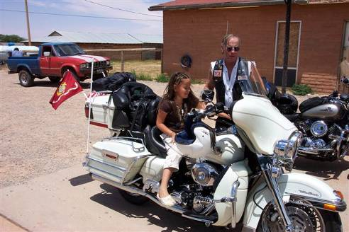

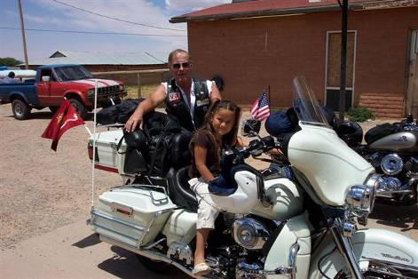

What fun. Leaving Lukachukai we headed East on 13 toward ‘Buffalo Pass’ 9784ft. As we entered the canyon we were struck by the beauty of the red canyon walls surrounded by green vegetation and multiple colors. As we proceeded thru the canyon and up the mountain we encountered a family driving their cattle to the high elevation summer feeding grounds. This is a common occurrence this time of year and quite spectacular to witness. As we rode past the cattle Robs bike spooked a cow with her calf and she stopped and lowered her head and horns at Joe. She backed off as Joe rode by. What an experience. As we started down the East side of ‘Buffalo Pass’ the well-known landmark ‘Shiprock Peak’ was visible for many miles. We arrived in Farmington about 3PM fueled the bikes and went to our hotel. We picked this hotel because it had a Spa & Pool. We were informed at check-in that the pool and spa was not available due to painting. Was this a sign? No worries, off to the bar for a cool one. The hotel was located right next to the San Juan River, which was fast flowing this time of year. We enjoyed the setting had a nice dinner and retired for the night.
Monday June 4th 2007

Farmington, New Mexico to Ouray, Colorado 127 Miles

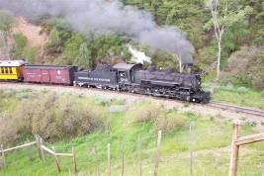
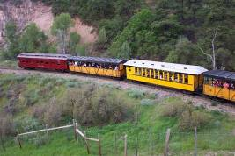
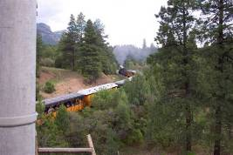
Up around 5:30AM. Enjoyed a hot breakfast at the hotel and then off to Durango, Colorado which is the southern terminus of the Durango-Silverton Railroad. We stopped in Durango for a cup of coffee and a break. As we rode up the mountain we passed the second train to Silverton, Colorado of the day. Further up the mountain we stopped at a bridge where the train crosses under the highway for a photo opportunity. We met a few folks and got some nice photos of the train as people greeted us with waves of joy as they proceeded up the mountain. After the train passed some folks asked if they could take some pictures of the 3 Amigos. We are slowly gaining fame! As we rode up the mountain we passed Aspens with new bright green leaves, following the cascading Animas River, and viewed many side streams and waterfalls all with a backdrop of snow-capped mountains. As we approached Silverton, Colorado the clouds were getting darker. We parked in Silverton and covered our bikes as a few drops of rain fell. We went to a nice coffee/pastry shop to wait out the rain. 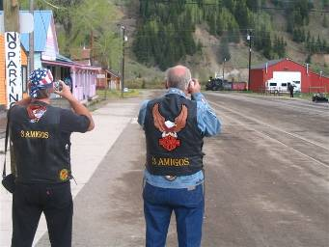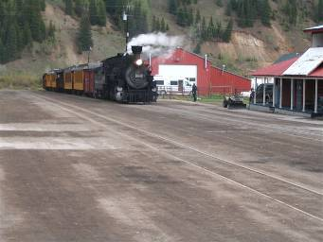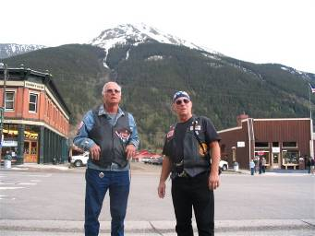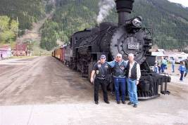
We did some sightseeing, watched the train arrive and had a nice lunch. There was very little rain. We put our rain gear on, uncovered our bikes and rode on to Ouray. The highway between Silverton and Ouray is called the ‘Million Dollar Highway’ due to all of the high-grade gold and silver ore used in its construction.
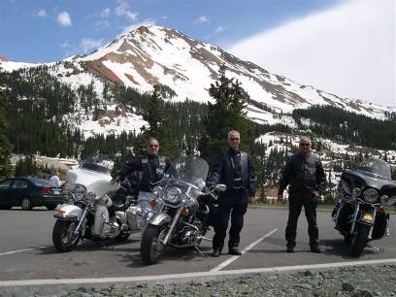

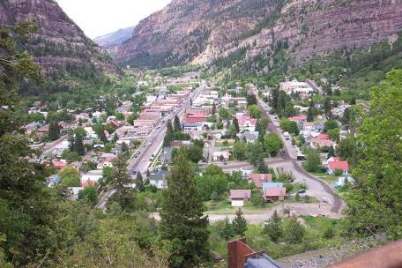

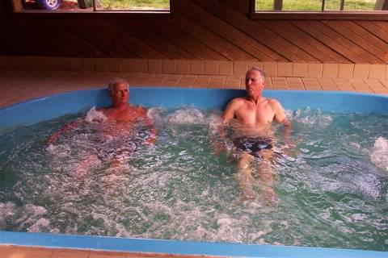

The approach to Ouray ‘Little Switzerland’ is magnificent. We stopped at an overlook for some pictures. We arrived at the Twin Peaks Hotel about 3PM. This hotel has two spas fed by natural hot springs. We enjoyed happy hour while sitting in the spa. Rob and Joe walked into town for a nice dinner as Mike retired early. Ouray is truly spectacular.

Tuesday June 5th 2007

Ouray, Colorado to Leadville, Colorado – 237 Miles

Nice morning with a very light cloud cover. Enjoyed a hot breakfast at the hotel and prepared for our ride to Leadville, Colorado. As Joe was leaving the hotel his bike did not feel right. He asked Mike, over the radio, if his rear tire looked OK. Mike answered in the affirmative so Joe rode on. Joe stopped on the road just outside of the hotel got off of his bike and confirmed a flat rear tire. Not a problem. Rob confirmed that a large staple was in the tire. Joe got the ‘Tire Flat Fix’ can out of his saddlebag and repaired the leak, used Rob’s air compressor to inflate the tire and the 3 Amigos were of to Leadville. Rode to Ridgeway for fuel then off to Montrose where we stopped at an auto parts store to replace the ‘Tire Flat Fix’. From Montrose we headed East on 50 to Gunnison, Colorado where we stopped for fuel and a cool drink. At Poncha Springs, Colorado we turned north on 285 heading for Leadville. Arriving in Leadville we stopped at the famous ‘Delaware Hotel’ in the center of town finding that there were no rooms available. The receptionist at the hotel put her arms around the 3 Amigos and found us a room at the Silver King Inn. After checking in to our hotel, which was a ways from the ‘old center of town’ we took a short walk to procure some provisions for happy hour. Dinner was at the Pizza Hut across the street then to bed early.

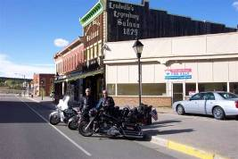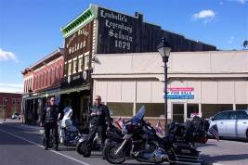

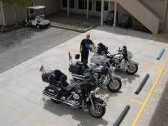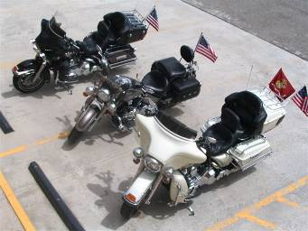

Wednesday June 6th 2007

Leadville, Colorado to Ouray, Colorado – 278 Miles

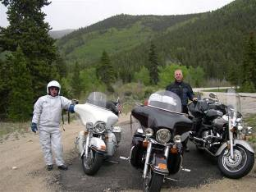
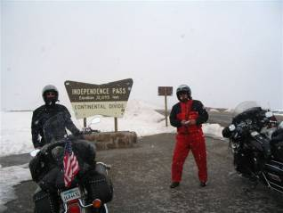
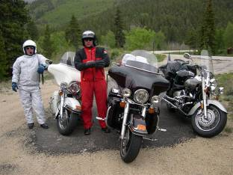
After breakfast at the Inn we prepared for the days ride with no particular destination in mind. Riding South on Hwy 24 to Hwy 82, about 15 miles South of Leadville, Joe’s radio was not working well. Rob noticed that the antenna was missing from Joe’s bike. Back to the Inn for the antenna which Joe left in the room. On the way back to Hwy 82 we noticed very dark and heavy clouds west of us against the mountains. We turned west on Hwy 82 toward Twin Lakes, Independence Pass and Aspen. After passing through Twin Lakes we decided that we should stop and put on our foul weather gear. A light rain turned to hail as we were suiting up. As we road through a valley on the approach to Independence Pass a moderate rain turned to snow. As we rode the twisting mountain road toward the summit the snow was becoming heavier and heavier. At the summit, 12,095ft it was almost a whiteout. We stopped at the summit for a photo opportunity. 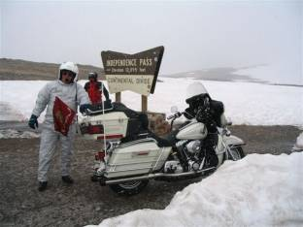
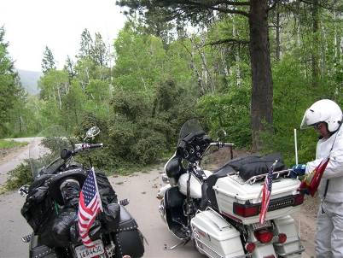
As we descended the mountain we were puckered up and riding with extreme caution. As we approached Aspen we encountered heavy winds. We rode through Aspen toward Snowmass stopping for fuel west of town. The winds became stronger as we rode toward Carbondale, Colorado. At the intersection of Hwy 82 and Hwy 133 we turned south and stopped at a 50’s style diner for lunch. After lunch, still wearing our foul weather gear, we rode south on Hwy 133 encountering high winds and rain. About 25 miles south of Carbondale we turned east to visit Marble, Colorado. On the road to Marble we came across several downed trees and lots of debris on the road.

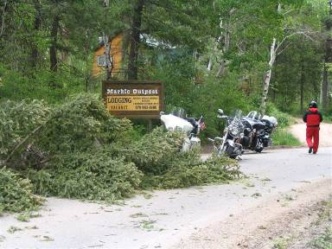

Back to Hwy 133 we stopped in Hotchkiss, Colorado for a cool drink and to remove our foul weather gear as it was warming up. We stopped in Delta, Colorado for fuel. The rain had stopped but the winds were quite severe so we decided to head south on Hwy 550 to the hotel in Ouray and enjoy the natural spa. We arrived in Ouray about 5PM exhausted. We were able to get the same nice room that we had two nights ago. After a good soak, happy hour and some snacks we visited with some nice folks and then retired for the night. This was a day that will forever be imbedded in the minds of the 3 Amigos. I am sure that the stories of the crossing of Independence Pass will get better over time.

Thursday June 7th 2007

Ouray, Colorado to Chino Valley, Arizona 478 Miles

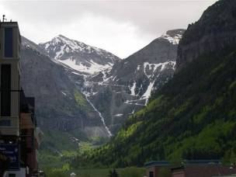
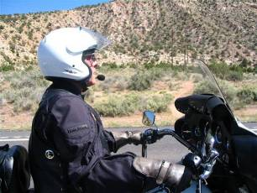
After another nice breakfast at this hotel we cleaned our windshields and headed north on Hwy 550 to Ridgeway, Colorado and then headed west on Hwy 62. 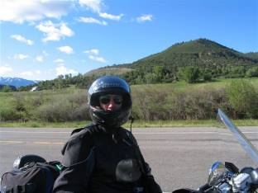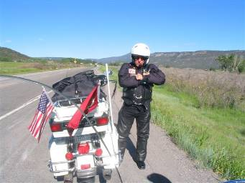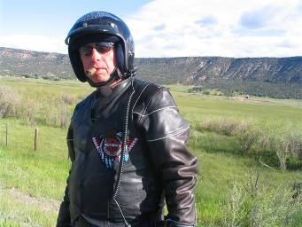At the junction of Hwy 62 and Hwy 145 we headed southeast on Hwy 145 to Telluride, Colorado. We found that Telluride is still quite beautiful but is not as quaint and laid back as it used to be. After a cup of coffee and a stop for fuel we headed back to Hwy 145 turned south and stopped at an overlook for some pictures. The road from Telluride to Dolores, Colorado is a nice ride. You parallel the Dolores River and pass many farms and ranches as you descend to lower elevations. The winds had subsided considerably, which made the ride very pleasant. We stopped for Coffee and a short break at Dolores, Colorado. At Cortez, Colorado we found a self-service car wash and cleaned all of the ‘Independence Pass’ dirt and grime off of our bikes. 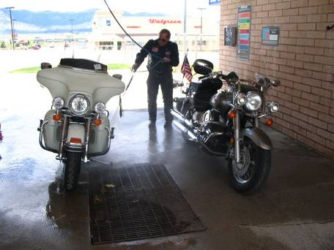We discussed our next destination and decided to start the ride toward our homes. We stopped for fuel at the Indian Casino about 10 miles south of Cortez. Joe called his friend, Bill, who lives in Chino Valley, Arizona to see if a visit was appropriate. Bill responded come on down! We then headed south on Hwy 160. At the junction of Hwy 160 and Hwy 491 Mike continued south on Hwy 491 toward home and Joe & Rob headed southwest on Hwy 160. We stopped at the 4 Corners Monument (the intersection of Utah, Colorado, New Mexico and Arizona) for a few pictures. 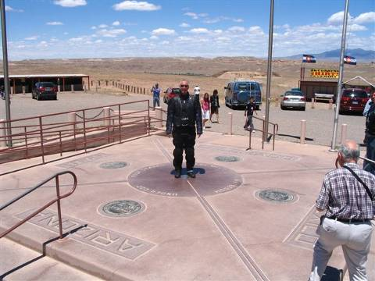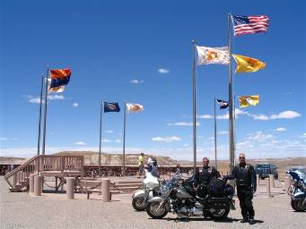Quite a few bikers were stopped here as well. We then stopped at Tes Nezlah, Arizona and had a cool drink. We then rode on to Kayenta, Arizona where we stopped for fuel. There are certain road signs that folks on motorcycles do not like to see. We rode for about one hundred miles passing ‘Fresh Oil’ signs and some obvious fresh oil. We finally caught the fresh oil truck. Fortunately it was in the opposite lane. At the intersection of Hwy 160 and Hwy 89 we turned south on Hwy 89.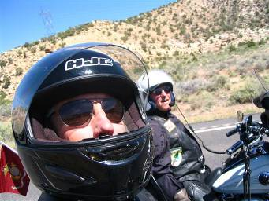 We stopped about 10 miles north of Flagstaff, Arizona for fuel. As we approached Flagstaff we were confronted with road construction. Taking a small risk we made the correct decisions to get us out of traffic and on
I40/66 south toward Ash Fork, Arizona. At Ash Fork we headed south on Hwy 89 to Bill’s house arriving about 6:30PM. Bill had a few friends over who greeted us on arrival. After a few cool ones and games of horseshoes we enjoyed BBQ steaks, potatoes and asparagus.

Friday June 8th 2007

Chino Valley, Arizona to Parker, Arizona 167 Miles

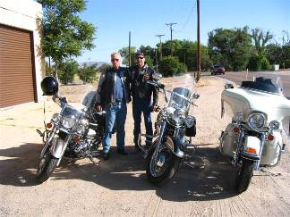
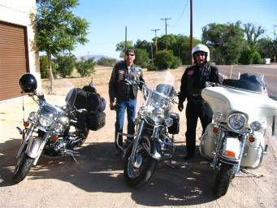
After coffee and cereal we cleaned the bikes and headed for Joe’s vacation house at the Parker Strip on the Colorado River. Bill rode with us and took us on a scenic ride through Skull Valley, Arizona to Kirkland Arizona where he bid us farewell. We headed southwest on Hwy 89 to Congress, Arizona where we intersected Hwy 71 then to Hwy 60 and on to Wenden, Arizona where we stopped for fuel. Riding through desert country we then turned northwest on Hwy 72 at Hope, Arizona and then to Parker, Arizona where we stopped for a short break. The weather was mild and pleasant for this time of year. Heading east on Hwy 95 we followed the river to Joe’s place. After cleaning the bikes we took Joe’s jeep to the casino for a nice dinner buffet and a chance to pay for the trip. Back at the river house Rob went for a swim and we retired for the night.

Saturday June 9th 2007

Parker, Arizona to Torrance/Carlsbad, California 287 Miles

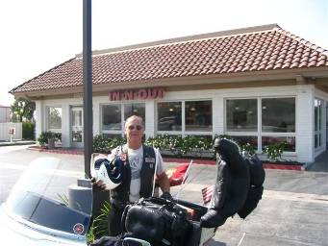
Up early for coffee, granola bars and a banana we prepared for our ride home. We stopped at the new Chevron station in Parker for fuel. We headed north on Hwy 95 crossing the Colorado River into California then west on Hwy 62 to Joshua Tree, California for a fuel stop. 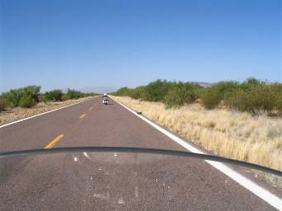At the intersection of Hwy 62/I10 we rode west on I10 past Beaumont, California where we turned southwest on I60. We stopped in Moreno Valley, California for an early lunch at the In&Out Burger at about 9:30AM. We found that they did not open until 10AM. Hey, we’re ready for In&Out Burger - so we’ll wait. After some good healthy food we headed home. Rob turned south on the 215 freeway and I went northwest to intersect the 91 freeway and home.
This would conclude the 2007 ‘3 Amigos’ ride. We look forward to riding again in 2008. As we age, 61, 64, and almost 66 our sense of adventure and wonderlust is alive and well. We love the wind in our face, the warmth of the sun and sometimes the rain, snow, sleet and hail on our windshields as we enjoy the anticipation that comes with visiting our great country.

Trivia:
We rode twenty-five hundred and ten miles over nine days and eight nights. We made twenty-two fuel stops, stayed five nights in hotels and three nights in private residences. Joe’s Harley Davidson consumed 53.3 gallons of fuel for an average of 47 miles per gallon.

