3 Amigos 2008 Ride

There are only a few highways that run from the Canadian border through the United States to the border with Mexico. One such road is Highway 191 http://www.untraveledroad.com/Categories/Highways/USHighway191.htm, which has its terminus at Morgan, Montana and Douglas, Arizona, a distance of approximately 1811 miles. The Highway runs through Montana, Wyoming, Utah and Arizona, skirting the western borders of Colorado and New Mexico. The Highway passes some of the most beautiful scenery west of the Rocky Mountains including Yellowstone National Park, Grand Teton National Park, Arches National Park, Canyon de Chelly National Monument and many other Points of Interest. One of the highlights is the Coronado Trail http://www.roadtripamerica.com/drives/Coronado-Trail.htm in Arizona.

The 3 Amigos (3 brothers age 67, 65, 62), exercising their love for adventure and wanderlust, that is part of their DNA, decided to start their adventure on Thursday May 22nd and ride from their individual homes to Saint George Utah. Rob and Joe would meet just North of San Bernardino, California (Joe riding a 2002 Harley Davidson Electra Glide Ultra Classic & Rob riding a 2002 Yamaha V Star 1100). Mike (riding a 2005 Harley Davidson Electra Glide Ultra Classic) would ride directly from his home in Gallup, New Mexico. After an overnight stop in Saint George the 3 Amigos would ride to Idaho Falls, Idaho for their second overnight. From Idaho Falls the plan is to ride to Malta, Montana for an overnight rest and then on to the Canadian border to start the trip south. The first three nights of the trip will take place over the Memorial Day weekend. This is the reason that pre-planned stops and hotel reservations were made.

When the 3 Amigos depart the Canadian border Sunday morning May 25th they will not have any plans where they will stop or spend the night. This is in keeping with their longing for adventure that is a tribute to their father, Leo, who built this into their activities as they were growing up. His greatest quote was “I wonder where that road goes”.

The 3 Amigos invite you to ride along with us:

Following is a day-by-day recap of our adventure.

Thursday May 22 – Torrance, CA – Carlsbad, CA – Gallup, NM to St. George, UT

After a week of very high temperatures across the Western United States it is cooling off. The weather report calls for a chance of showers all the way to the Canadian border. Mike (Amigo #1) got excited and left yesterday for St. George UT spending the night in Kanab UT. Rob (Amigo #3) and I (Amigo #2) left our homes about 6:30AM with plans to meet at the Summit Café at the top on Cajon Pass on Interstate 15. I arrived at the summit about 9AM when I received a cell phone call from Rob. His motorcycle had quit running about a half mile from the summit. As I prepared to go assist him he called and had got it running and was on his way. We fueled our bikes and started our journey together riding north on I15. We experienced wind, rain and even some sunshine. Rob’s Yamaha quit running several times with what appeared to be fuel starvation. Just short of St. George it quit again. We diagnosed the problem and found that the fuel vent line was kinked and created a vacuum in the fuel tank. This explained the series of shutdowns. We arrived in St. George to find Mike waiting for us outside the Best Western Hotel. Rob readjusted the fuel line and we put the bikes to bed. We enjoyed Happy Hour and a nice dinner. We returned to our room and retired early.
Totals for today = 411 miles, riding 7 hours 25 minutes – California, Nevada, Arizona & Utah.

Friday May 23 – St. George, UT to Idaho Falls, ID

We rode out of St. George, after an early breakfast, and found ourselves surrounded by storm clouds. It had snowed in the higher elevations during the night. As we approached Fremont Pass the trees were covered with a light coat of fresh powder snow. Some snow had accumulated beside the highway but the roadway was clear. We had some sunshine as we passed over the summit at 6680 feet. Light rain was falling as we came to our first fuel stop of the day. Snow-covered mountains with patches of sunshine surrounded us. We pulled into a rest stop a few miles up the road and decided that this would be a good time to put on our rain gear. This turned out to be a good decision. The next 300 miles was through light rain with a few patches of sunshine. The final 115 miles was in very heavy cold rain. Just outside Pocatello, Idaho we stopped for fuel and a light dinner. About 50 miles from Idaho Falls the rain became extremely heavy. We arrived at our Best Western hotel, during a heavy downpour, about 5:30PM. The rain lightened up so Rob took a walk and picked up some Jack Daniels. We had a delayed Happy Hour and went to bed. This was a tough day!
Totals for today = 515 Miles, riding 10 hours 21 minutes – Utah and Idaho

Saturday May 24 - Idaho Falls, ID to Malta, MT

We rode out of Idaho Falls at about 7AM with cloudy skies but no rain, yet. We passed fresh snow as we climbed to a little over 6800 feet. The mountains that we could see below the clouds were beautiful. We rode through the mountains for about 200 miles with only intermittent light rain. We rode the next 363 miles in the rain experiencing heavy downpours at times. We never saw the sun again this day. We crossed over the Continental Divide several times. Outside of Great Falls, MT. we rode through a beautiful gorge and discovered the headwaters of the Missouri River, crossing over it several times, as we headed toward Butte, Mt. Approaching Havre, Mt. we noticed ‘Road Work Ahead’ signs. We had ridden through many such areas so far with no difficulty. This was going to be different. The entire main street of this town was torn up leaving pot holes filled with water and a muddy mess. The bikes performed well and we were able to negotiate the heavy, now off road motorcycles, into a gas station without an incident. After fueling and while trying to get back onto the main ‘off road trail’ my bike fell into a ditch and broke off the kickstand spring. I looked down and saw the kickstand flopping around and made a right turn and stopped. Rob brought over a bungee cord and secured the kickstand in the up position. Now every time we stop I would need one of the Amigos to come over and put the kickstand down for me. I was a hostage! A few miles out of Havre we saw the ‘Road Work Ahead’ sign. What are we in for now! Yep, they had torn up all lanes of the highway leaving us with another ‘off road’ experience for the next 6 miles. We proceeded through mud, potholes, and cars passing and slashing mud on us. Somehow we kept the metal side up as we slid around on these heavy bikes. What an experience. We arrived safe in Malta, MT and checked into our triple suite room. Our motel was right out of the movie Psycho and right across the street from the train tracks. Wet and worn we turned on the oven and put our gear next to the stove to dry out. After cleaning up we went to the local Casino/Restaurant and had dinner. Malta is a small ‘Americana’ town. We found the people to be very nice and accommodating. Off to bed a little late today at 11PM.
Totals for today = 563 Miles, riding 11 hours 7 minutes – Idaho and Montana.

Sunday May 25 – Malta, MT to Lewistown, MT

I woke up after a restless night listening to the raindrops hitting the window air conditioner outside of the room. What a hoot! The Canadian border is about 54 miles North of Malta. We headed for the border in the morning rain. The border crossing is a pretty simple arrangement. We stopped on the USA side and took some pictures and then started our ride down Hwy 191 to Mexico. We encountered some high winds and more rain on the ride back to Malta where we had breakfast and fueled the bikes. We inquired about the road conditions on Hwy 191 south of Malta and were informed that there was a washout about 40 miles down the road, but not to worry because we only had to cross about 100 feet of gravel. I had learned how to operate my bungee cord kickstand without assistance so I was independent again. It continued to rain with a very cold wind. We rode through rolling hills to the washed out road. I watched a car plow through the slush, mud and gravel to our side of the washout. It did not look good for us motorcycle riders. I proceeded into the washed out area and immediately sank down to my footboards. Somehow I was able to power through to the other side. Mike and Rob followed close behind me. After getting back onto the asphalt I noticed that my kickstand was flopping around again and the bungee cord was gone. Rob came to my rescue again and attached a new bungee cord. We pressed on to our second fuel stop of the day in Lewistown, MT. It was about 2PM. After fueling we decided to stop for the day as we were wet and cold and we were tired. We found a nice Hotel/Casino, covered our wet and muddy bikes, and took a short rest. After cleaning up we took a walk to the downtown area. We found Lewistown to be very nice with an older type movie theater. The most recent Indiana Jones movie was playing so we purchased tickets at $5.50 for seniors and experienced a bit of hometown America and their great movie theater. We then returned to our room for Happy Hour and a warm and good sleep.
Totals for today = 243 Miles, riding 5 hours 43 minutes – Montana and the Canadian Border

Monday May 26 – Memorial Day – Lewistown, MT to Bozeman, MT

We departed Lewistown about 9AM. We rode through fog for many miles and then rain, some clearing and more rain. We arrived in Bozeman about noon and checked into our hotel. I had called ahead to Yellowstone Harley Davidson to inquire if the service department would be open and to make arrangements to have the kickstand spring installed and a few other issues taken care of. We were informed that the local Harley Owners Group was hosting a Memorial Day BBQ so we headed for the dealership. The folks at Yellowstone Harley were great. Dan, the Service Manager, took care of getting my bike repaired. Jim, the Parts Manager, helped me with the additional parts I needed and Dave the Technician did the work. We decided to have our bikes professionally washed. This would take some time so we all enjoyed the BBQ and met some real nice folks. We did some shopping in the apparel department and admired all of the new Harleys on display. We met Hank in the sales department and had a great time talking with him. Rob called his wife, Lori, and was telling her all about the new Harleys when she suggested that maybe he should think about getting a nice used one someday. Rob mentioned that to Mike and myself and I, of course, suggested that we should ask Hank if he had any good used bikes. Well, we were having such a good time, the folks were so nice and we didn’t have anything else to do so Rob purchased a nearly new 2007 Electra Glide Ultra Classic. I couldn’t believe it. How cool. Rob will be riding his new Harley the remainder of the trip. We are truly the 3 Amigos. I would be remise if I didn’t mention how neat it was to see his wife Lori give him encouragement and support as he worked through the decision to purchase the Harley. What about his Yamaha you ask? Rob is having it shipped home. The clouds were preparing for their afternoon shower so we headed back to the hotel and put the bikes to bed. This was laundry day for us so we started the wash and took a trip to the spa. We had a short Happy Hour and celebrated Rob’s new Harley and retired for the night. We just know that tomorrow is going to be a great day for our ride.
Totals for today = 165 miles, riding 3 hours 43 minutes – Montana

Tuesday May 27 – Bozeman, MT to Pinedale, WY

Our bikes and we were clean and dry as we departed Bozeman about 7AM. We were all suited up and prepared for more rain. Not to disappoint us it started to rain as we exited the freeway and resumed our trek on Hwy 191. It continued to rain until we got to the outer boundary of Yellowstone National Park. We had heavy clouds as we entered the town of West Yellowstone but no rain. After a nice country breakfast we rode to the entrance to the park where Rob purchased his Golden Eagle Pass. This was a milestone since he was now 62 and could now just show his card and ride on as Mike and I had done on previous rides. The weather was kind to us as we rode through the splendor of Yellowstone. We arrived at Old Faithful just after her performance so we waited the approximately 90 minutes for the next one. We then rode on seeing Buffalo, Deer, Antelope, Elk and many other wild creatures. Yellowstone is truly a wonderful experience, especially on a motorcycle. Our average speed was about 35mph, which allowed us to absorb the beauty around us. As we left Yellowstone we entered Grand Teton National Park. The mountains were spectacular with a great deal of snow. We stopped in Jackson Hole for fuel. We found Jackson Hole to be a typical tourist town with lots of people and traffic. We rode on longing for the less traveled country roads that we have enjoyed so much. We needed a quiet mountain town for the night and Pinedale, WY appeared to fit our needs. We called ahead and made a reservation at the Best Western and rode the 84 miles to Pinedale. We picked up some Jack Daniels, enjoyed Happy Hour and then walked to the locale Subway for a healthy dinner. Our room had a nice view of the snow packed mountains. This was a great day. It has been warmer and dryer and we finally have some blue sky. We packed our rain gear and stowed it for the last time this trip.
Totals for today = 301 miles, riding 10 hours 55 minutes – Montana - Wyoming

Wednesday May 28 – Pinedale, WY to Monticello, UT

Woke up to a day of clear sky, snow capped mountains and riding dry. What a treat. This was to be a motorcycle rider’s day. We pressed on today riding in cool temperatures as we passed rolling hills and deep canyons. We experienced some high winds as we passed through Flaming Gorge National monument. This is beautiful country. It was so enjoyable to see all of the red rock and wonderful formations. We stopped for the night at the Days Inn in Monticello, UT. This motel was very nice with great service. We normally clean our bikes after each days ride. This was the first time that we had an opportunity to clean our bikes ourselves this trip. It is so nice to be dry! We look forward to another great day tomorrow.
Totals for Today = 492 miles, riding 11 hours 44 minutes – Wyoming - Utah

Thursday May 29 – Monticello, UT to Springerville, AZ

We woke up to another morning of blue sky’s and pleasant cool temperatures. Had a nice healthy breakfast, packed the bikes and prepared for another great day. It was a little chilly so I decided to warm my bike up. It would not start! After much troubleshooting and tearing it apart in the parking lot we got it started. Hold the excitement, it was not charging properly. Rob was not feeling well and since my bike was not feeling well either, we decided to abort the Hwy 191 trip and head for Farmington, NM via Cortez, CO. There is a Harley shop in Farmington so our best shot would be to head that way and not take the chance that the bike might break down in the middle of nowhere. We had ridden about 40 miles towards Cortez when my bike decided to fix itself and started operating properly. We turned around and headed back to Monticello to resume our trip down Hwy 191. The weather was pleasant as we rode through the Navajo and other Indian Reservations stopping for lunch in Chinle, AZ, the gateway to Canyon de Chelly National Monument. It is necessary to ride with elevated caution on the Reservation as it is an ‘open range’ and horses, cattle and dogs freely wonder onto the roads. We encountered some wind as we started the slow climb to Springerville, AZ. Our little detour today only cost us about 80 miles and 90 minutes. It appears that our goal of reaching the Mexican border is within our reach. We stopped at the Best Western in Springerville for the night, cleaned the bikes, enjoyed happy hour and went to bed.
Totals for today = 386 miles, riding 8 hours 2 minutes – Utah – Colorado - Arizona

Friday May 30 – Springerville, AZ to the Mexican Border to Benson, AZ

My bike started just fine this morning. We departed Springerville about 6:30AM for an early start on the Coronado Trail. Stopped for fuel at the quaint mountain town of Alpine, AZ about 26 miles from Springerville. We rode most of the 100 miles of the twisty Coronado Trail at speeds of 25 mph or less. The trail is a great scenic ‘motorcycle road’ and lots of fun. Approaching Clifton, AZ, at the southern terminus of the trail, we rode through a giant copper mine. Yes, you actually ride through the mine. This is quite spectacular and something that we will never forget. Clifton is an old, but very active, mining town situated in a gorge with a winding river and many old buildings. We stopped for fuel in Wilcox, AZ. I noticed that the right forward exhaust pipe heat shield on my bike had come loose and was about to fall off. I just removed it and put it in my tour pack for the rest of the trip. Chiricahua National monument is about 45 miles from Wilcox and a great side trip. We have visited there in the past and recommend it if time permits. We continued on Hwy 191 arriving at the unofficial end of Hwy 191 about 1:45PM. We then took Hwy 191 Business through Douglas, AZ a few miles to the Mexican Border to the official end to Hwy 191. After taking a few pictures and having lunch we headed to Benson, AZ via Bisbee, AZ and Tombstone, AZ. This road has great scenery and provides a great ride. The weather had become warmer, to about 103 degrees, at Douglas. We arrived in Benson about 5PM and checked into the Best Western Motel. The pool looked very refreshing so we walked across the street and picked up a couple of sixer’s of cold beer. We enjoyed some pool time and a few cold ones as the weather was very pleasant. Tomorrow we start the trip home.
Totals for today = 358 miles, riding 9 hours 4 minutes - Arizona

Saturday May 31 – Benson, AZ to Torrance, CA, Alta Loma, CA and Gallup, NM

After a nice breakfast at the Best Western we rode to Tucson, AZ and stopped to visit Mike’s son and our nephew Leo and his son Tony. Mike left us at Leo’s to ride home to Gallup. Rob and I headed for Peoria, AZ where Rob’s wife Lori was visiting her Aunt Marcella. Lori was impressed with her & Rob’s new ride so all is well! As we left Peoria the temperature was approaching 100 degrees. Rob and I decided that we would stop for the night if it became to hot and we became fatigued. We stopped several times and soaked our shirts for a little cool down as we rode through the desert. It was a pleasant ride so we decided to press on. Rob and I split off to our respective destinations at the interstate 10/15 interchange. The temperatures cooled down as I headed toward the beach. I arrived home tired and hungry. I put my bike in the garage and embraced my homestead.
Totals for today = 583 miles, riding 11 hours 43 minutes – Arizona – California – New Mexico (Mike)

Epilogue

The 3 Amigo’s had set a goal and have successfully attained it. We rode four thousand seventeen miles in ten days. In retrospect, we have decided that we will not do this type of ride again. All of our previous rides have allowed us to be much more flexible. We will plan future rides with less planning! Flexibility is necessary when riding motorcycles. We must be able to change our course and take that unknown road to find out where it goes. Hopefully in nice weather! We hope that you enjoyed your ‘armchair’ ride with us.

Photos

Rob leaving Carlsbad Joe preparing to leave Torrance

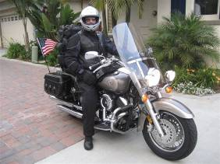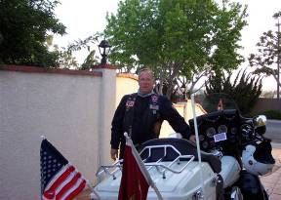

First fuel stop after St. George Putting our rain gear on
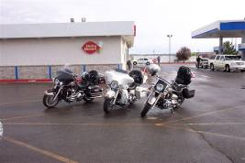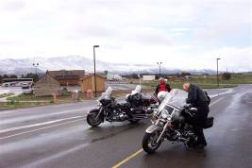

Our second fuel stop on Friday Mike and Joe – Happy Hour - Idaho Falls
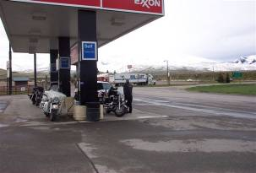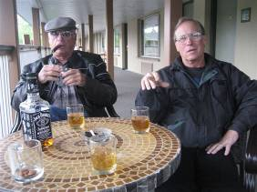

Snake River Falls across from our hotel Rob’s Yamaha on arrival in Malta, Mt
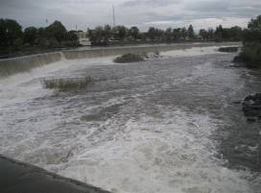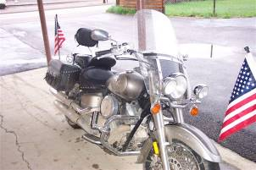

Joe’s Harley on arrival in Malta, MT Drying our gear on the stove
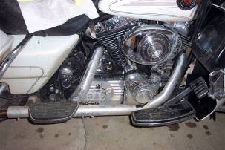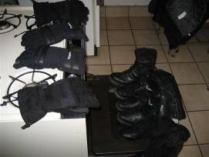

More gear drying The 3 Amigo’s at USA/Canada border
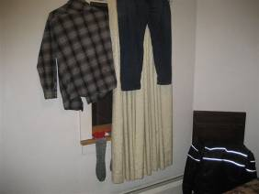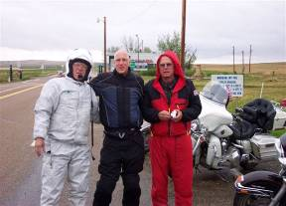

Warming up and breakfast in Malta, MT Rob’s new Harley Bozeman, MT
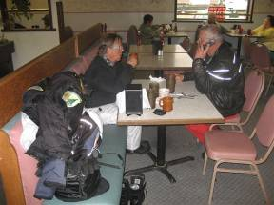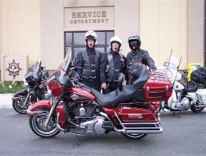

The 3 Amigos & Rob’s new ride Breakfast West Yellowstone, WY
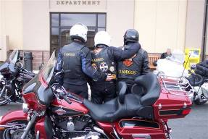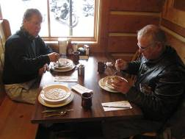

Entering Yellowstone Nat’l Park Crossing the Continental Divide - Again
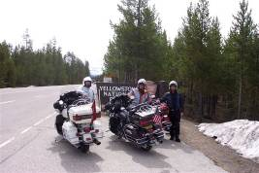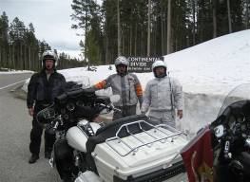

Entering Grand Teton Nat’l Park Flaming Gorge Nat’l Recreation Area
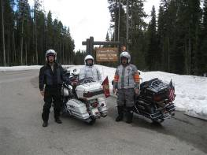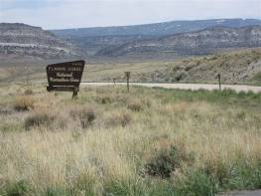

Flaming Gorge Dam & Reservoir
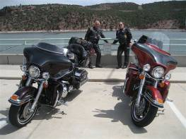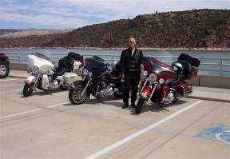

Fixing Joe’s broken Harley - Monticello, UT
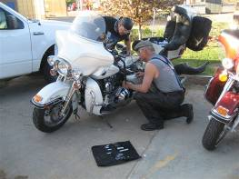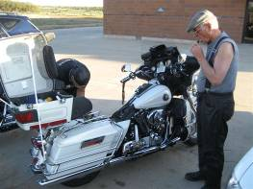

Springerville, AZ Beginning Coronado Trail Alpine, AZ
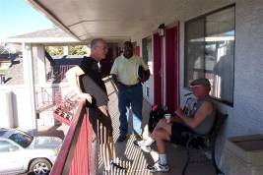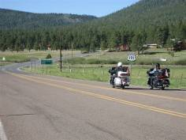

Rob - Coronado Trail Joe - Coronado Trail
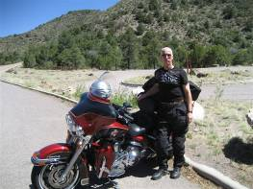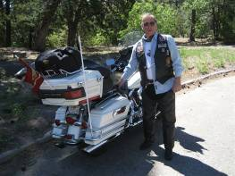
Along the Coronado Trail Giant Copper Mine at Clifton, AZ
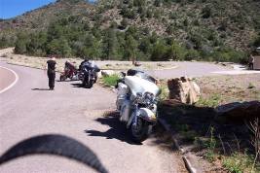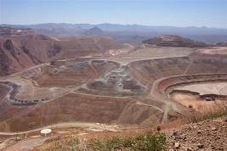

Taking care of parts that fell of Joe’s bike – Wilcox, AZ
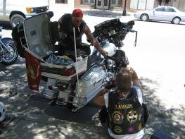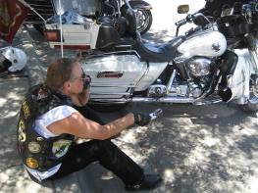

The end of Highway 191
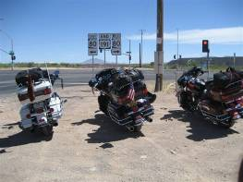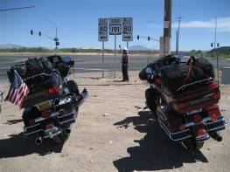

The USA/Mexico border Rob & Leo
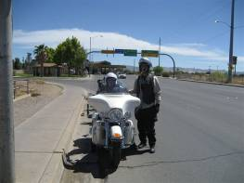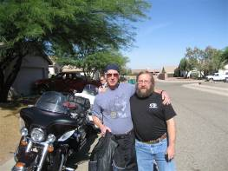

Lori admiring her & Rob’s new ride
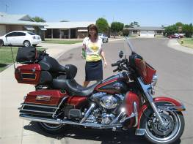

That’s All Folks

