The 3 Amigos ride was a little late this year due to circumstances beyond our control. After much thought and planning with weather being our major consideration, we elected to make Big Bend National Park in Southwest Texas our destination. On Thursday October 29th I rode from Torrance, CA to my younger brother, Roberts, house in Escondido, CA for the night. I traveled 112 miles today.

We left early Friday morning for a long ride to Willcox, AZ via Tucson, AZ. Our original plan was to meet our older brother Mike in Tucson; however we changed our plans due to snow and cold temperatures at his home in Gallup, NM. Mike will start a day later than he planned (today) and meet us at a yet to be determined place subject to the weather. We started our ride a little before dawn to avoid the normal workday traffic. We found the freeways very well illuminated so it was a nice ride out of town. Riding East on I8 we observed a pretty sunrise and a sense of freedom as we left the congested area of San Diego. Our first fuel stop was El Centro, CA. As we passed through Yuma, AZ I checked my GPS and told Robert that we should have enough fuel to make Gila Bend, AZ. The sky was clear and the morning air a little brisk. It was a great day for riding. About thirty miles from Gila Bend Robert told me that his low fuel light had illuminated (we communicate with radios while riding). We reduced our speed to 65MPH, the speed limit is 75MPH, and waited for the sputter of our engines as we ran out of fuel. I counted down the miles as we approached Gila Bend. We rolled into the first gas station somewhat elated that we actually made it there. I put 5.03 gallons in my tank that is rated at 5 gallons. I am sure that I arrived running on fumes. After lunch we headed for Tucson and on to Willcox arriving a little after 3PM. After checking in to our hotel we decided to ride to the Chiricahua National Monument. The Monument is located in the Chiricahua Mountains about 37 miles from Willcox. There is much history here with wonderful rock formations and many hiking opportunities. Much of the area is sacred to the Indians that inhabited the area many years ago. We returned to Willcox for a nice dinner. Mike called and let us know that he was in Las Cruces, NM getting his motorcycle serviced and would meet us in El Paso, TX tomorrow in the afternoon. Rob & I traveled 611 miles today. Mike rode 338 miles today.

Rob and I both slept well. We had breakfast, cleaned our bikes prior to heading to Columbus, NM. As we were preparing our bikes I could not find my iPod. (I connect the iPod to the bike stereo system for some entertainment while riding.) Rob and I checked everywhere. No iPod. I finally realized that I probably left it on the bike and somebody took it. Oh well, nothing I can do now. We rode out of Willcox enjoying a brisk morning and clear skies. As we rode I just happened to check my vest pocket. Oops, my iPod was snuggly resting there. This getting old is getting a bit bothersome! Just after crossing the New Mexico border we stopped at the old town of Steins. Steins is an old railroad watering place in the day of steam engines. The property was purchased a few years ago by a couple. They restored some of the buildings and have kept the others in a state of repair. Steins is a nice place to visit, however it is easy to miss. From Steins we rode to Columbus, NM via Animas and Hatchita, NM. Columbus is about three miles north of the Mexican border and is where General ‘Black Jack’ Pershing assembled his army to chase Poncho Villa after he attacked the United States at Columbus. We visited the museum that captures the history of the area very nicely. From Columbus we rode along the US/Mexican border on a very nice road to El Paso, TX. Mike was waiting for us at our hotel. This is the ‘official’ beginning of the 2009 3 Amigos ride. We put the bikes to bed, enjoyed ‘happy hour’ and took a cab to the nearby casino for dinner and a little luck. We enjoyed a nice evening at the casino. Robert won $150.00, Mike won $450.00 on his last pull of the slots. I did not win a cent. Well, actually I did not lose as Robert bought drinks and dinner and Mike paid for our hotel. So, all of the Amigos were winners! Tomorrow we head for Big Bend National Park. Rob and I rode 268 miles today. Mike rode 48 miles today.

We were up at 5AM looking forward to a great day of riding. We left El Paso about 7AM and rode Interstate 10 to Van Horn, TX. At Van Horn we turned south heading to Marfa, TX. We passed pecan orchards and miles and miles of open dry fields. Marfa, TX is where the movie ‘Giant’ was filmed in 1956 with James Dean, Rock Hudson and Elizabeth Taylor. Marfa remains a central service town for the area. Heading southwest out of Marfa we rode through rolling foothills to the town of Presidio, TX which is situated on the border with Mexico. Presidio is a small town in comparison to Manuel Ojinaga, MX which is across the Rio Grande River. From Presidio we rode east along the Rio Grande river. This road is adjacent to Big Bend State Park and rises and falls with twists and turns through very pretty country. There is a great deal of wildlife in this area. We rode with caution as we observed a few ‘less fortunate’ animals that had met there fate on this stretch of road. We passed through the small resort town of Lajitas, TX. Lajitas provides the ‘high end’ accommodations for this relatively remote area with many amenities including the rare opportunity to play golf. We arrived in our destination town of Terlingua, TX a little after 3PM. Terlingua is a former ‘ghost town’ that was revived several years ago when the ‘Annual Texas Chili Cook-off’ was set for this site. This event is held in November every year and draws hundreds of participants and chili lovers. The event will take place the week-end after we depart. Our accommodations in Terlingua are at the Chisos Mining Company motel. At check-in there was no computer as the lady thumbed though her ledger to find our reservation. We were given # 19 ‘The Rock House’. This accommodation is very quaint and funky to say the least. No telephone, no radio, no television. There are two rooms with four beds, a table, a refrigerator, a small kitchen and one amenity, a clock. Access is via a dirt road. This was the perfect accommodation for the 3 Amigos for the two days that we will be there. We rode to the gas station, a short distance away, and then found the Chili Pepper Café’ for our dinner. We returned to our ‘suite’ to enjoy the evening. As we were sitting outside enjoying the sunset and twilight and watching the full moon rise, the coyotes began to howl. There on top of a close ridge was the profile of ‘Wiley Coyote’ howling to the moon with other coyotes responding. Although we had all spent much time in the desert and heard the howl of the coyotes, we had never actually seen the profile of the coyote raising and lowering his head as he howled to the moon. The evening was brisk and pleasant with the silence only broken by the coyotes howl. We rode 331 miles today.

Up early, as usual. We rode to the Ghost Town Café for breakfast. The food was great and we had a nice time with Paula who took good care of us. We fueled our bikes and headed for the entrance to Big Bend National Park four miles away. After entering the park we rode for several miles on the main road gaining altitude and then turned into a beautiful canyon that leads to the Chisos Mountain Lodge and the main visitor center. The ride through this area was spectacular with mountains surrounding us, many trees, awesome rock formations and beautiful desert flora. This location is known to have many mountain lions and bears. These animals are rarely seen except by the hikers in the early mornings or at dusk. We did see many Roadrunners, Kangaroo Rats, Javalina (wild pigs), hawks and an occasional Golden Eagle. Leaving the visitors center we rode back to the main road and headed for the farthest point in the park that is on a paved road. At the Rio Grande Visitor Center we received advice on the best places to view the Rio Grande River and the Mexican Village of Boquillas del Carmen across the river. Prior to 9-11 there was a border crossing here and people were allowed to cross the river to enjoy this remote and quaint Mexican village. After 9-11 the border crossing was closed and the villagers suffered greatly. It is now illegal to cross the river here. As we approached the scenic overlook we spotted native crafts displayed on the rocks for sale. The villagers across the river leave carved walking sticks and handmade items with a price list and a jar to put your money in if you purchase something. While we were there two villagers appeared from across the river. We had a nice time visiting with them. If the Park Rangers come, the villagers go back across the river in their small boat or on horseback. They must take all of their items with them or the rangers will confiscate them. We left the area and rode a short distance to a trail that leads to a magnificent view of the river and village. We hiked to the top and Robert hiked down the other side to the river and the entrance to a large gorge. When Mike and I returned to the parking lot two villagers appeared on horseback. They then disappeared on the trail. What a unique experience for us. As we waited for Robert to return three men rode in on matching motorcycles. We found that they were also brothers and did a ride together every year. They mentioned that they would be the Tres Amigos and have vests made like ours. It is, indeed, a small world. Our last adventure of the day was riding 60 miles to the Castolon Visitors Center and Santa Elena Canyon River Access. Here we observed 1500 foot cliffs where the river flowed out of a gorge. The Rio Grande River is described as an arcing oasis, a ribbon of green that cuts across the dry desert and carves deep canyons. Riding out of this marvelous place we saw Javalina, Roadrunners and other desert creatures. Returning to Terlingua we passed the cemetery where a ‘Day of the Dead’ event was forming. We arrived at the old ghost town where folks were enjoying happy hour. Many folks were sitting or walking the boardwalk enjoying their libations. We ordered our food to go from the Starlight Theater (café) and headed back to our ‘Rock House’ for our happy hour and dinner while enjoying yet another spectacular sunset. We rode 178 miles today.

Today is a brisk beautiful day. We rode to Fort Davis, TX via Alpine, TX. We enjoyed breakfast at a nice hometown café. We then rode the scenic loop to the observatory and around the mountains back to Fort Davis. We observed several Javalina and other wildlife. The leaves were turning their bright autumn colors and blowing in the slight breeze as the season was changing. From Fort Davis we headed to Pecos, TX. We stopped early today and checked into the Best Western Swiss Chalet and Suites. This is a new property and a very upscale Best Western Hotel. Today is laundry day for us so we put our clothes in the washers and spent some time in the hot tub and indoor pool. Robert needs a new rear tire. There are no motorcycle shops close by so he arranged to have the tire replaced tomorrow in Alamogordo, NM. We rode 254 miles today.

We enjoyed a very nice ‘cooked o order’ breakfast at the hotel. The owners of this hotel emigrated from Switzerland. The breakfast selection included Birchermüesli which was developed as a healthy food for the Swiss Army. All of the ingredients are from Switzerland. This was a special treat. As we rode out of Pecos we observed many boarded up buildings. The town appeared to be quite depressed. We chose a route to Carlsbad Caverns that took us on an old farm road. We, again, observed Javalina and many domestic animals as we passed field after field of Alfalfa. Carlsbad Caverns was a great experience. We arrived early and enjoyed a walk through the ‘Big Room’. Very few people were in the room. We nearly had this popular place all to ourselves to enjoy the silence and nature’s beauty. Leaving Carlsbad Caverns we rode north to Artesia, NM and then west over the mountains to Alamogordo, NM. The ride over the mountains was pleasant and spectacular. There were patches of snow in the higher elevations. Arriving in Alamogordo we checked into our hotel and took Robert’s bike to the shop for a new rear tire. After retrieving the bike from the shop we enjoyed ‘happy hour’ and walked to a restaurant for dinner. Alamogordo was unusually warm for this time of year. We would have enjoyed a dip in the pool; however, since they had already experienced their first freeze, it had been drained. We rode 289 miles today.

We left the hotel after our continental breakfast and rode to White Sands National Monument about thirteen miles southwest. Since we were early we had White Sands all to ourselves. We spent some time at the visitor center and then rode the scenic drive through the monument. The white sand dunes were quite impressive. It was a bit of a challenge riding through the sand for a short distance after the paved road ended. Leaving the monument we rode to Truth or Consequences, NM via Las Cruces, NM. We fueled our bikes and headed south for about ten miles then turned west to cross the mountains toward Silver City, NM. The Mimbres Mountains offer a beautiful and challenging ride. We rode over Emory Pass at 8228 Ft. Just prior to Silver City we turned south to Deming, NM. This will be the final stop for the 3 Amigos this trip. In the morning Mike will head home to Gallup, NM via Hatch, NM and Robert and I will head west. We rode 298 miles today.

Rising early today we all got an early start with Mike heading home to Gallup and Robert and I heading for Wellton, AZ. Just prior to reaching Tucson, AZ we left Interstate 10 and turned west to ride through the Tohono O’odham Indian Reservation. We stopped for fuel at Why, AZ. Why, AZ is about 27 miles north of Organ Pipe Cactus National Monument and the Mexican border crossing at Lukeville, AZ. We found that the annual International Motorcycle Rally was taking place this week-end at Rocky Point Mexico. Rocky Point is about 95 miles south of Why, AZ. We observed many motorcycles heading south as we rode north to intersect Interstate 8 at Gila Bend, AZ. We expected it to be a hot day as we rode through this area. We were pleasantly surprised with a nice cloud cover (the first time this trip) that presented us with a pleasant cool ride. We arrived in Wellton, AZ, about 35 miles east of Yuma, AZ, in the late afternoon. We fueled and cleaned our bikes, enjoyed a nice dinner and prepared for our trip home tomorrow. We rode 476 miles today. Mike rode 372 miles today.

We departed Wellton about 7AM with clear skies and a brisk chill. We stopped for fuel at the Golden Acorn Casino about 35 miles west of El Centro, CA, paid our dues at the casino, and rode on. As we approached San Diego Robert turned north on Interstate 15 to his home and I headed to Interstate 5 and home. I rode 317 miles today. Robert rode 229 miles today. Mike arrived home yesterday.

Epilogue: We were blessed with wonderful weather during this trip. I (Joe) rode for 10 days and 3134 miles. Robert rode for 9 days and 2934 miles. Mike rode for 9 days and 2108 miles.
The 3 Amigos (Brothers – Mike 68, Joe 66 and Robert 63) look forward to 2010.

Chiricahua National Monument http://www.nps.gov/chir/index.htm
Big Bend National Park http://www.nps.gov/bibe/index.htm
Terlingua http://www.historic-terlingua.com/historic_terlingua_ghostown_001.htm
Boquillas del Carmen http://en.wikipedia.org/wiki/Boquillas_del_Carmen
http://www.wfaa.com/sharedcontent/dws/news/world/mexico/stories/111507dnintcanyonsinger.2ab2e5d.html
Carlsbad Caverns http://www.nps.gov/CAVE/index.htm
White Sands National Monument http://www.nps.gov/whsa/index.htm

Leaving Roberts House
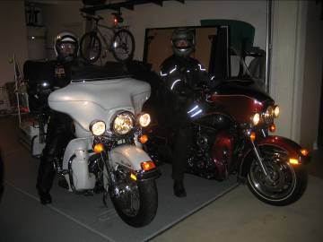
Chiricahua National Monument
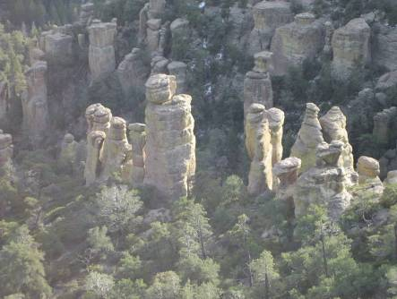

Steins New Mexico
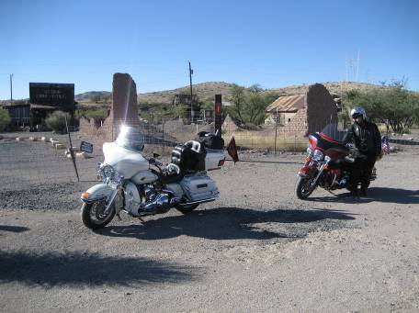

Columbus New Mexico
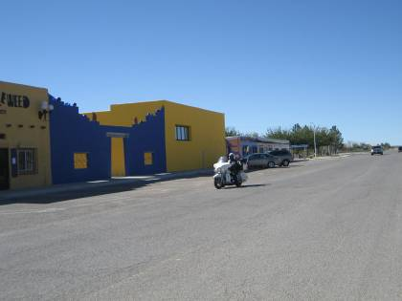

Meeting Mike in El Paso Texas
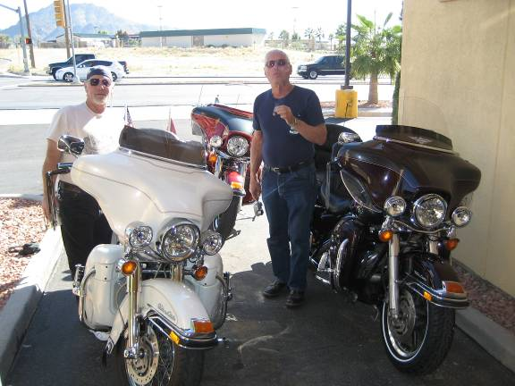

On the Road From Van Horn, Texas to Presidio, Texas
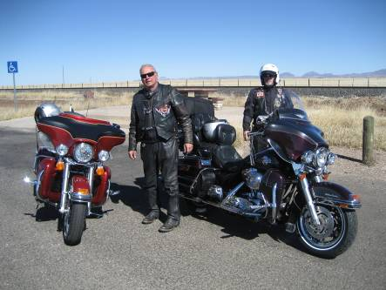

Getting Our Picture Taken By The Border Patrol
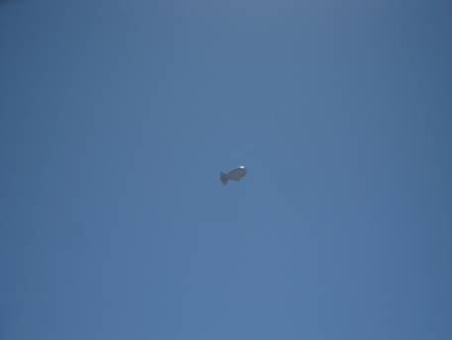

On the Road From Presidio, Texas to Terlingua, Texas
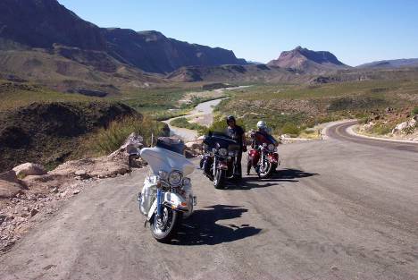

On the Road From Presidio, Texas to Terlingua, Texas
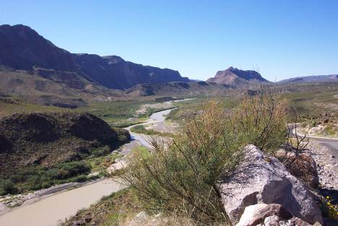

Chisos Mining Company Motel 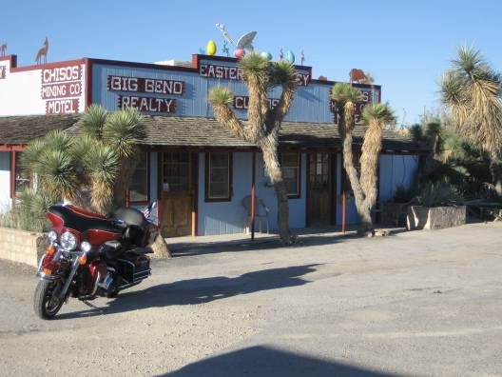
The Presidential Suite at the Chisos Mining Company Motel
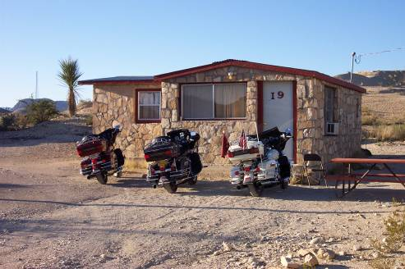

Visiting Big Bend National Park
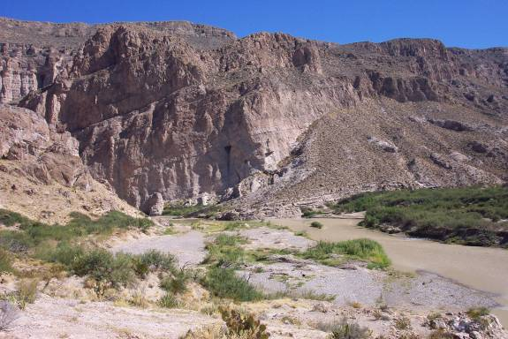

Visiting Big Bend National Park
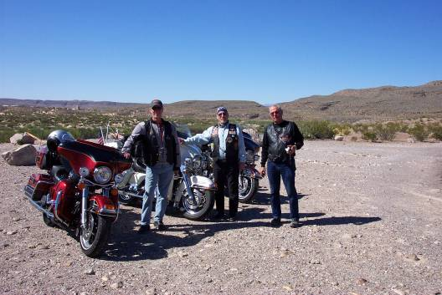
Visiting Big Bend National Park
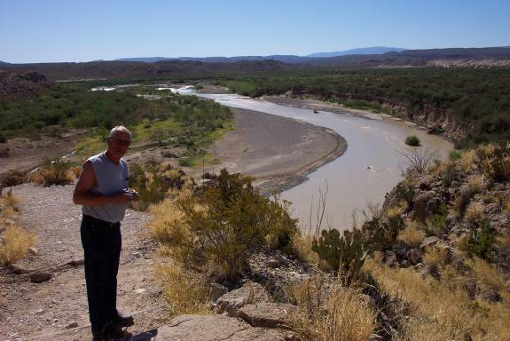

Folks From Across the River (Mexico)
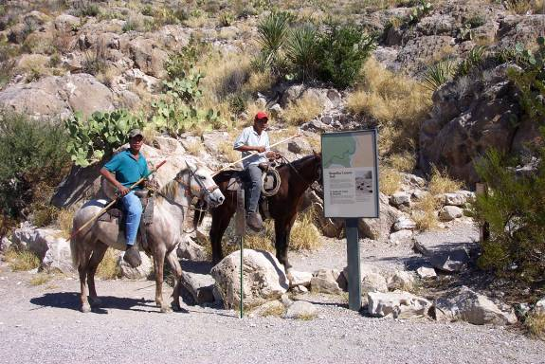
Items for Sale From Across the River
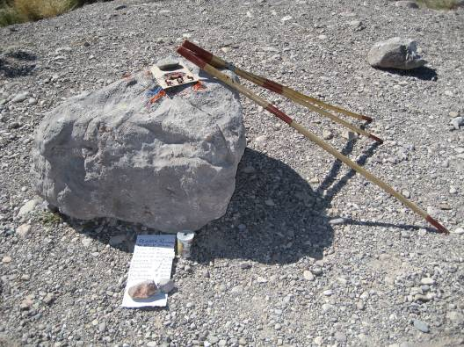
Castolon Visitors Center in Big Bend National Park
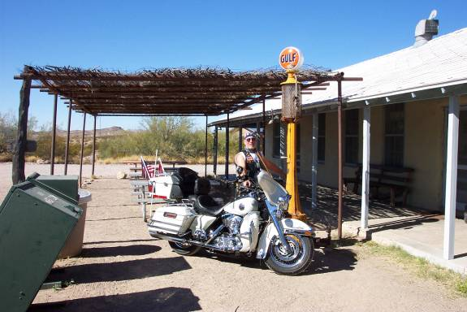
Visiting Big Bend National Park
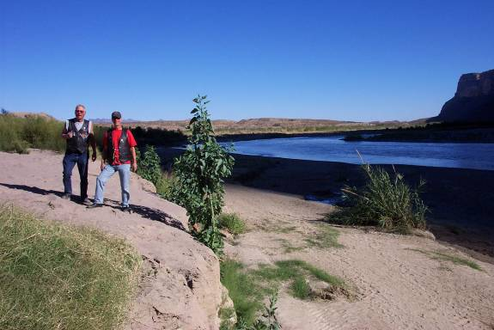

Visiting Big Bend National Park
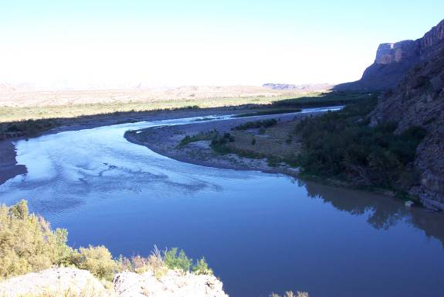

Mike Restocking
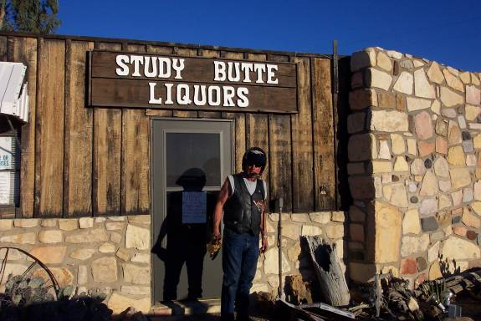
Where the Folks Gather in Terlingua
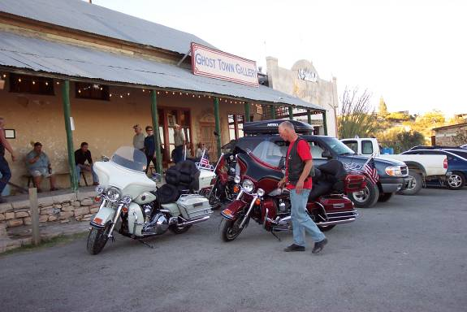
Breakfast at the Ghost Town Cafe'
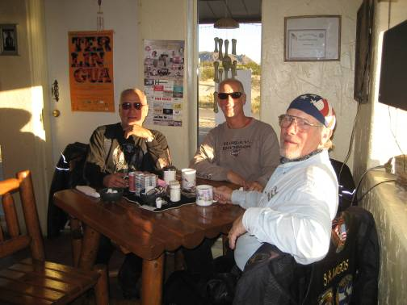
Carlsbad Caverns
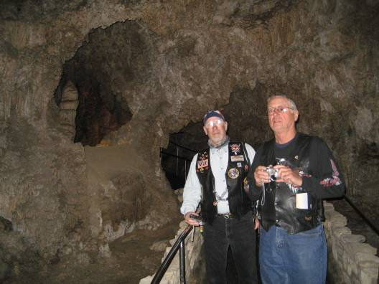
White Sands National Monument
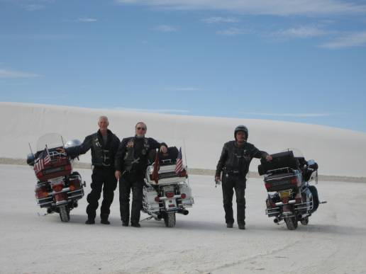
On Our Way Home
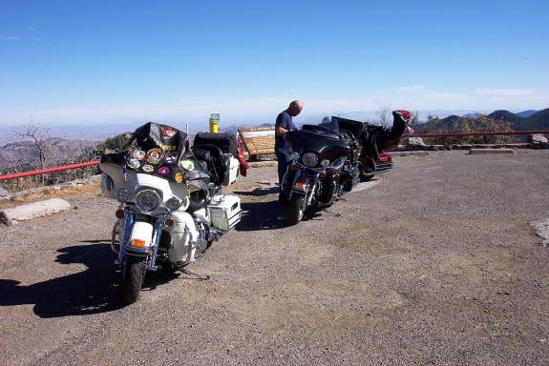

THE END

