The 3 Amigos ride was put together quickly as the ‘Brothers’ are all busy with other issues this year. We found that July 20th – July 26th would work for all of us. Our plan is for Robert and me to depart our homes at about noon on Tuesday July 20th and meet at the route 66 ‘Summit Inn Café’ at the summit of the Cajon Pass near Victorville, CA. We would then ride to Primm, NV for the night. Mike will ride from his home in Gallup, NM and overnight at Jacob Lake, AZ near the North Rim of the Grand Canyon. We will all meet near Colorado City, AZ where the 3 Amigos Ride 2010 will start.

Tuesday July 20th

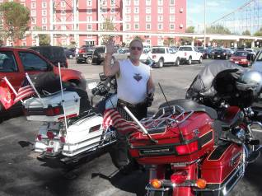
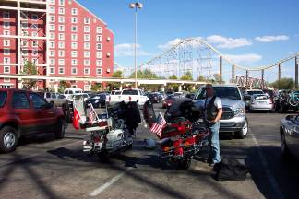
I left home at 11AM today. The weather was cool with a nice breeze. I rode to Alta Loma where I had lunch with my brother-in-law Bill. I met Rob at the Summit Inn about 1:30PM. The temperature was beginning to rise. We rode on to the Outlet Stores near Barstow where we fueled our bikes. It was now over 105 degrees. Anticipating hot weather, Robert and I had purchased Harley Davidson Hydration vests. These vests work much like an evaporative cooler. You soak the vest in water and wear it under a jacket that has perforations or vents. We decided that this would be a good time to try our vests since temperatures were expected to rise above 116 degrees on our ride to Primm. We stopped in Baker, CA for a cold drink and to re-hydrate our vests. The temperature was 120 degrees. As we ascended Baker Grade the temperature fell to about 110 degrees and was about 107 degrees when we arrived at Primm about 4:30PM. The cooling vests worked wonderfully. We fueled our bikes and checked into Buffalo Bills Hotel & Casino. I had reserved our room through Expedia at a cost of $16.00 + $1.00 tax. We were pleasantly surprised at the size and cleanliness of our room. We cleaned up, left a few bucks at the casino for future players, had dinner and retired for the night.

I rode 253 miles today. Rob rode 258 miles and Mike rode 353 miles.

Wednesday July 21st

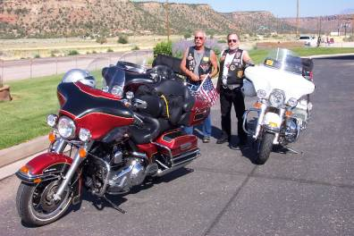
I woke up about 2:30AM and took a shower. I looked around Buffalo Bills for coffee and found none. I walked over to the gas station and picked up two cups of coffee. Back in the room at 3:30AM Rob was still sleeping. I woke Rob and went to the front desk and checked us out of the hotel. We packed our bikes and rolled out of Primm at 4:50AM. There was a false dawn and our bikes are well illuminated so it was bright and clear riding on the freeway at this time of the morning. We rode through Las Vegas at dawn. The traffic was light and the morning air felt good at about 80 degrees. We stopped in

Mesquite Nevada for breakfast at a casino just off of Interstate 15.We called Mike and set a time to meet. We rode to Saint George Utah and fueled our bikes. After Rob and I left Mesquite the scenery changed to pretty red foothills and green valleys. We would ride through this kind of scenery for the next few days. We rode through Hurricane Utah to the Little Creek Chevron Station and Country Store a few miles from Colorado City Utah where we met Mike.
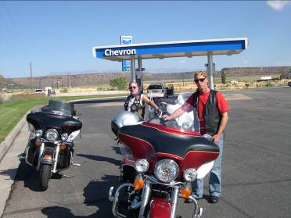
The 3 Amigos rolled on through Colorado City Arizona to meet Rob’s sister-in-law, Connie, at her place in Cane Beds Arizona. The rock formations were spectacular and the valleys were a rich green due to a very wet winter. We stayed at Connie’s place for several hours visiting her horses, relaxing and riding quads out to the cemetery where Rob’s brother-in-law Gary is buried.

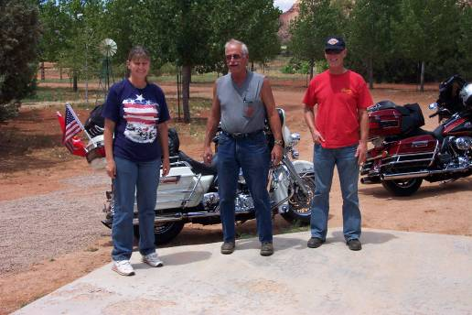

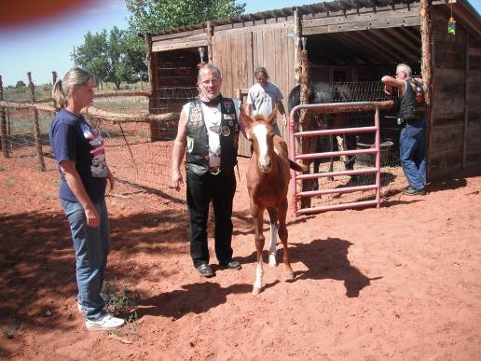

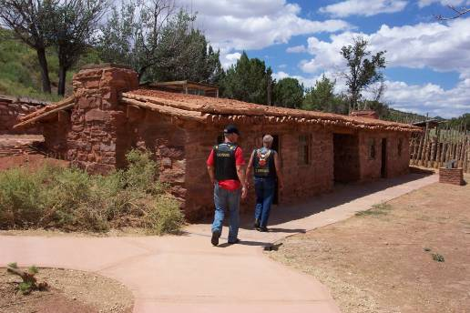

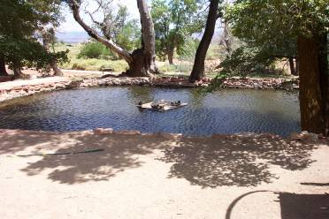
We left Connie’s about 1:30PM and rode to Pipe Springs National Monument. http://www.nps.gov/pisp/index.htm
We took the tour at Pipe Springs and learned a great deal about this wonderful source of water and life that has been available to folks for hundreds of years. We left Pipe Springs and rode through Fredonia Arizona to Kanab Utah. We checked into our hotel, had a swim, happy hour, dinner and retired for the night.

Rob and I rode 241 miles today. Mike rode 120 miles today.

Thursday July 22nd

Up at 5:30AM we showered, had breakfast and rode out of the hotel at about 7:30AM. We stopped at the west end of town to fuel our bikes. It was a beautiful brisk morning. We followed the East Fork of the Virgin River through beautiful canyons lined with 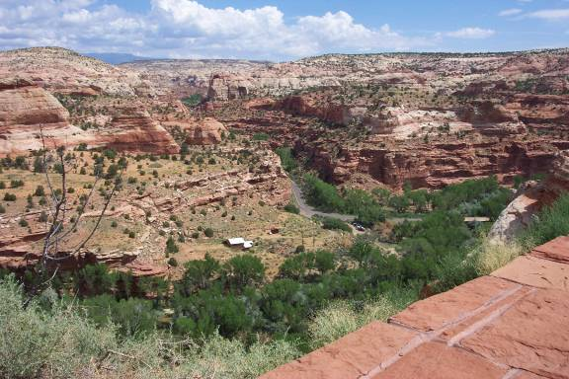 many green trees and valleys with cultivated fields with grazing cattle and horses. It got a bit cold so we stopped and put our jackets on. We turned East on Hwy 12 crossing the Sevier River towards Bryce Canyon National Park. http://www.nps.gov/brca/index.htm 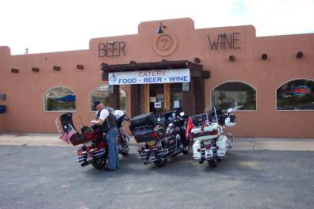We stopped in Escalante Utah for a coffee break. After leaving Escalante we started ascending with red rock walls on our right and a great gorge and the Escalante River on our left. The road then follows along a ridge with deep canyons on both sides. 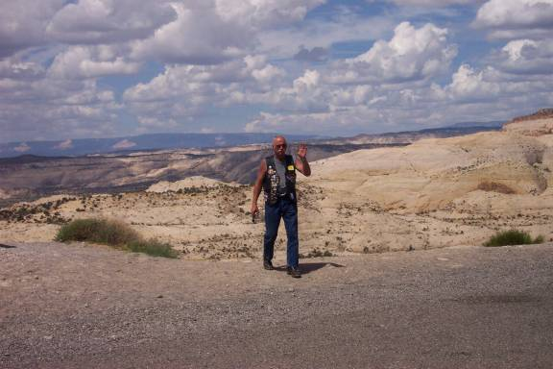The views are quite spectacular. We descended into Boulder Utah which is a pretty farming valley. From Boulder we ascended into the Dixie National Forest passing Pinion Pines, tall Pines and Aspen groves as we crossed the summit at 9600 feet. Thunder cells were moving about with a lightening strike here and there. We encountered a few drops of rain but somehow avoided a downpour. We arrived in Torrey Utah where Highway 12 ends and intersects with Highway 24. We fueled our bikes, had lunch at the Subway and headed east to Capitol Reef National Park. http://www.nps.gov/care/index.htm
On arrival at the Visitors Center we elected to take the 24 mile, round trip, scenic drive. We rode for about three miles through beautiful gorges and washes that had evidence of major water flows a short time ago. It started to sprinkle and then large drops of water began to fall with lightning in the distance. We decided to turn around as we did not wish to become stranded in the back country due to flooding. From Capitol Reef we rode east passing several areas that had recently experienced major flooding. The scenery on this road changes from red rock canyons and cliffs to sandstone canyons and cliffs and then a moonscape. We arrived in Hanksville Utah about 3:30PM and checked into the Whispering Sands Motel. We covered our bikes as there were heavy clouds and thunder cells in the area. We enjoyed happy hour and had dinner at Blondes Café across from the motel. Today was a pleasant ride with varying temperatures and spectacular scenery.

We rode 231 miles today.

Friday July 23rd

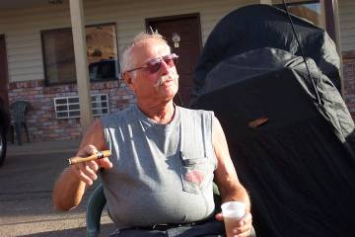
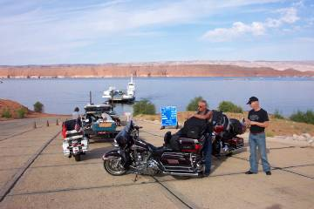
The Whispering Sands Motel was very nice. I was a bit concerned making advance reservations but since this was the only motel near the Bull Frog to Halls Crossing Ferry on Lake Powell, other than the high dollar accommodation at Bull Frog Marina, we took a chance. We were all up at 5:30AM packed our bikes and rolled off at about 6:30AM. We rode about 71 miles through spectacular scenery to the Bull Frog Marina ferry ramp. We arrived about an hour early and were third in line. After a few minutes a pick up with a large 5th wheel trailer pulled up behind us. I thought ‘how big is this ferry? Soon the ferry docked and three cars off loaded. We waited another half hour before we were allowed to board. The lake was calm so we had a pleasant crossing of Lake Powell. We stopped for coffee and fueled our bikes at Halls Crossing. We rode to the intersection of Hwy 276 and Hwy 95 and turned south for about nine miles. We then turned west on Hwy 261 heading to Mexican Hat Utah. We noticed a sign that said something like 10% Grade Ahead with Switchbacks – No Large Vehicles! This should be a great road for motorcycles. Mexican Hat Utah was about 34 miles distant. We rode Hwy 261 through rolling hills and moderate curves for about 24 miles. Then the sign appeared that stated ‘10% Grade Ahead – Switchbacks – Gravel Road for the Next 3 Miles’. Gravel Road? We do not care for gravel roads, especially with switchbacks and a steep grade. We started down like falling off of a cliff. We kept our speed at about 5mph, stopped for a few photo opportunities and passed several large motor homes ascending the grade.
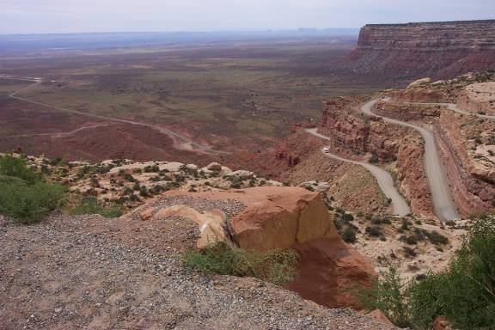 We later found that this is the famous Moki Dugway, http://www.midwestroads.com/otherstates/mokidugway/
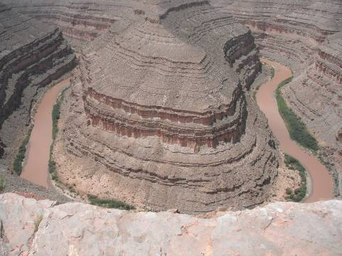
After descending the Moki Dugway we rode on to Mexican Hat Utah for lunch. After lunch we back tracked to The Goosenecks State Park. At the park we got an excellent
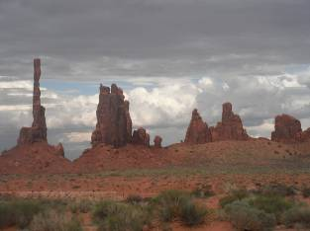
view of the famous Goosenecks on the San Juan River. After a few photo 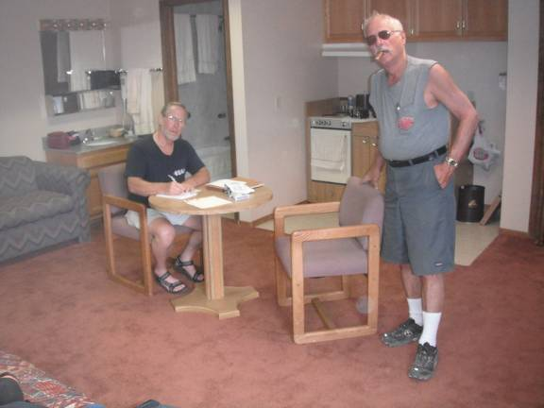opportunities and posing for tourists taking photos of us we rode on to Monument Valley and checked into our room at the Gouldings Resort. Mike has a relationship with the owners of the resort and had made prior arrangements for us. We were given the apartment at the airport. This apartment is not available to the public and is very nice with two queen beds, a hide-a-bed sofa, kitchen and flat screen television. The resort also provided us with a complimentary tour of Monument Valley. We elected to take the 4PM tour which is about 31/2 hours and goes to places not open to the public except for those on a guided tour. The tour was fascinating and informative. Our tour guide, Bennett, showed us many points of interest as well as old movie locations and explained Navajo history as it pertained to the area. From 1925 to 2007 over 53 motion pictures were filmed here including many John Wayne movies, ‘Easy Rider’, ‘Forest Gump’, Thelma & Louise’ and many others. We returned to the resort at about 7:30PM, enjoyed happy hour and had a light dinner. After dinner we sat outside and enjoyed the sunset and 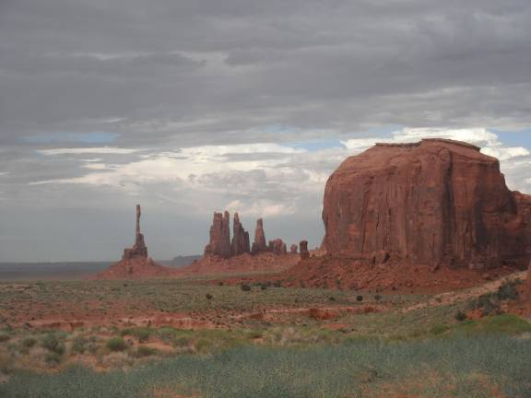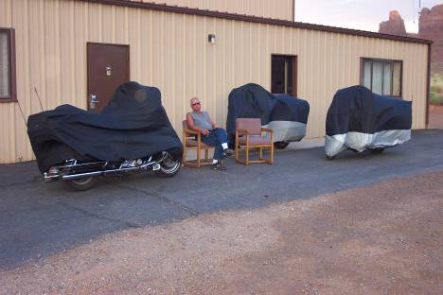
our fantastic view. After a few hands of cards we retired for the night.

We rode 204 miles today.

Saturday July 24th

We slept late today rising at about 7:30AM. We walked to the resort restaurant and enjoyed a delightful meal with a million dollar view of Monument Valley. After breakfast 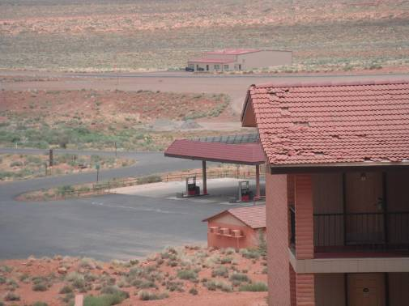
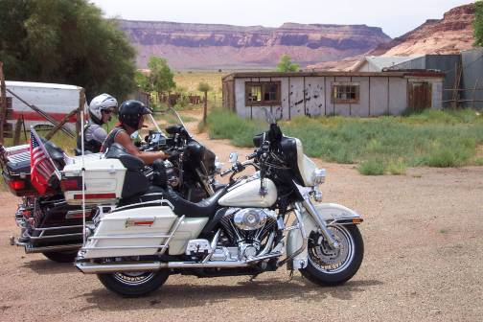
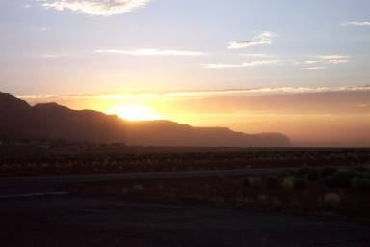
we toured the museum and became even more familiar with this magnificent place. Back to our room we rested for a few minutes then uncovered our bikes. We took a ride to the Oljto Trading Post. The trading post was closed and did not appear to be in operation. We 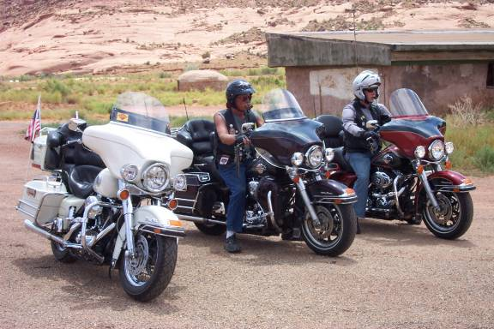headed back to Gouldings and then on to Kayenta Arizona. We fueled our bikes and had a cool drink. The temperature was pleasant with some cloud cover becoming hot in the afternoon. Returning to the Gouldings Resort we stopped at the, on site, market for dinner supplies to prepare at our apartment. After a nice happy hour we prepared our dinner and enjoyed another fantastic sunset. We then packed for tomorrows ride and retired for the night.

We rode about 55 miles today.

Sunday July 25th

While at Monument Valley we met many foreign tourists from Germany, Holland and France.
We awoke early, had coffee and breakfast snacks and rolled out of Monument Valley about 6:00AM. Mike was headed home to Gallup New Mexico and Rob and I headed to Laughlin Nevada. Rob and I rode to Tuba City Arizona for fuel and breakfast. We continued about ten miles to the intersection of Hwy 89. We headed south on Hwy 89 through Flagstaff Arizona to Interstate 40. We exited I40 at Seligman Arizona for fuel and a short rest. After we parked our bikes we noticed that we were the center of attention with several folks taking pictures of us. We posed with some of the tourists and the rolled 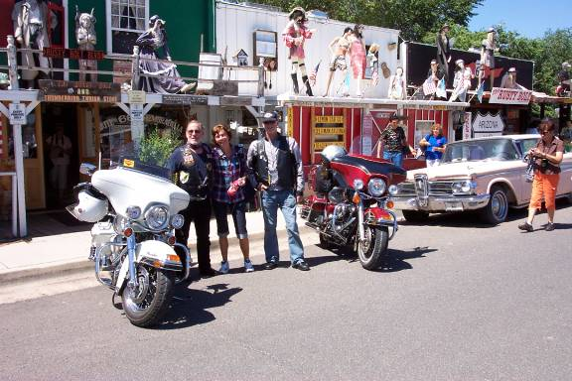out toward Peach Springs Arizona on ‘Old Route 66’. We stopped at the General Store in Hackberry Arizona for a cold drink. The general store and gas station has been saved as a step back into time and is a favorite stop on ‘Old Route 66’. 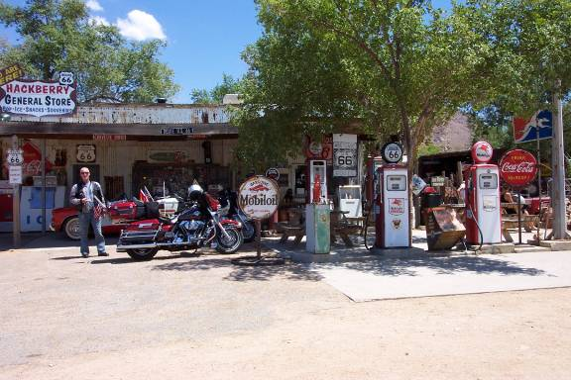http://hackberrygeneralstore.com/
The temperature was rising so we put on our cooling vests for the ride through Kingman Arizona and on to Laughlin Nevada. After we crossed Union Pass Summit (elev. 3625ft) and started to descend into Laughlin Nevada the temperature rose to 119 degrees. We rode to the Tropicana Hotel/Casino arriving about 2:30PM and parked our bikes in the covered parking garage as it was just to hot to park outside for check in. We walked to the front desk and checked in. Our room was not ready so we stayed in the casino cooling off. We finally received our room keys. We cleaned up, had dinner, played a few slots and retired for the night. The cool air conditioning was a refreshing respite.

Rob and I rode 363 miles today. Mike rode 192 miles to his home in Gallup New Mexico.

Monday July 26th

We woke early and had breakfast at the hotel. After fueling our bikes we rode out of Laughlin about 6:45AM. The temperature was 89 degrees. There were broken clouds that offered relief from the direct rays of the sun. Our cooling vests worked well and provided a pleasant ride on I40 to Newberry Springs California where we stopped for fuel. The temperature along I40 was pleasant and rather cool for this time of year. We rode through Barstow California and then headed south on Interstate 15. We stopped in Fontana California for a cool drink and to say our good-bys. Rob and I continued on I15 to the intersection of the 210 freeway where I exited and headed for home and Rob continued on I15 to his home in Escondido California.

Rob rode 323 miles to day and I rode 317 miles today.

Epilogue: We were blessed with wonderful weather and good times during this trip. Our Harley Davidson motorcycles performed well with no problems. I (Joe) rode 1664 miles. Robert rode 1675 miles. Mike rode 1175 miles.
The 3 Amigos (Brothers – Mike 69, Joe 67 and Robert 64) look forward to 2011.

