This year the 3 Amigos will ride to the very scenic state of Utah via Laughlin Nevada. We have visited Utah in the past and look forward to some of the stunning sights that reside there. Following is a brief day by day diary of our ride.

Day 1: Wednesday July 13th - Home to Laughlin Nevada
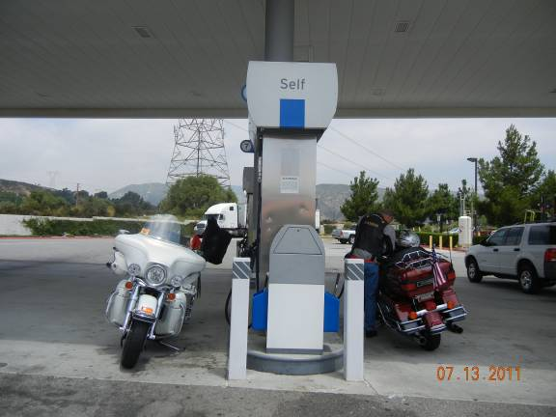
Joe and Rob left their homes in California about 11AM bound for Laughlin, Nevada. It was pleasant and cool riding to Barstow on Interstate 15 with the temperature slowly climbing to the triple digits. We stopped for lunch and fuel just South of Barstow at the Outlet Mall In-N-Out burger. A couple of tourist busses preceded us so it was a mass of people. After lunch we put on our hydration vests and thigh coolers (Rob made the thigh coolers) for the rather hot ride across the Mojave Desert on Interstate 40. We stopped at Ludlow, California to top off our fuel tanks and get a cool drink. We arrived in Laughlin at about 5PM and checked into the Tropicana Express Hotel and Casino. Mike had arrived a few hours earlier from his home in Gallup, NM and met us at our adjoining rooms. After resting a bit and cooling showers we headed to the casino. Of course, as usual, Mike came out ahead by many $$$. Rob and I were not so fortunate but had fun. Mike, as has been our tradition, treated Rob and I to dinner. We played a few more slots and then retired for the night looking forward to tomorrows ride.
Miles today - Mike 364 - Joe and Rob - 305

Day 2: Thursday July 14th - Laughlin Nevada to Beaver Utah
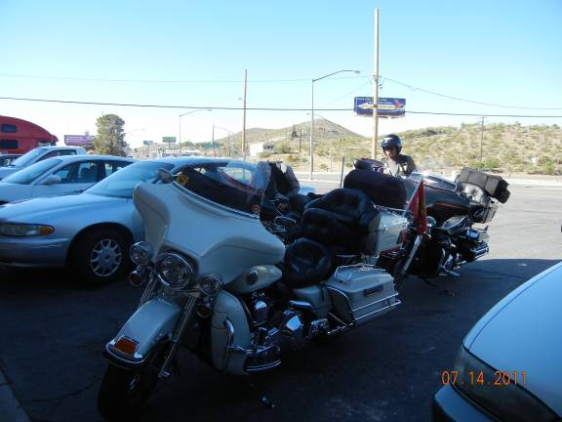
Up early we departed Laughlin in the coolness of the clear desert morning. Riding North on Hwy 95 we stopped at the Nugget Casino in Searchlight Nevada for breakfast. Rob sat down at a slot machine and immediately won $$ recouping his Laughlin losses and walking away a few $ ahead. We had a nice breakfast and Rob picked up the tab enjoining his winnings. We rode North on Hwy 95 and East on Hwy 93 to Boulder City Nevada where we fueled and stopped at the Coffee Cup Cafe' for a break. The Coffee Cup is located in the quaint old part of Boulder City and was recommended by our friends Warren and Geri Noack. Great place. We continued East on Hwy 93 then turned North on Hwy 166 (Lakeshore Rd.) then Northeast on Hwy 167 (Northshore Rd) to Interstate 15. Northshore Road follows Lake Mead with wonderful views of the lake and foothills. This route also allowed us to bypass

the hectic traffic of Las Vegas and ride slow and easy. We stopped in Mesquite Nevada for a cool drink. Continuing on Interstate 15 we rode through the Virgin River Gorge as we entered Utah. This a special sight as viewed from a motorcycle. We stopped for fuel just before Saint George Utah. On to Cedar City Utah for a late lunch/early dinner. We arrived at the Butch Cassidy Best Western in Beaver Utah at 5PM - one hour advance in time. Mike popped for the hotel sharing his good fortune from Laughlin. We enjoyed happy hour and a dip in the pool. We sat outside on the patio and dialoged with several people as they passed by walking their dogs. Mike retired early as he had injured his leg the day before the ride and needed to rest. Rob and I were surprised when Gilbert (the person who was working the front desk when we arrived) showed up and presented us with BBQ Tri Tip, potato salad and beans. What a treat. We talked for awhile and then retired for the night.
Miles today - 330

Day 3: Friday July 15th - Beaver Utah to Richfield Utah
We found Beaver to be a nice small town with horses and cows grazing in the many green fields that surround the town. The major industry in Beaver is a large hog farm that provides employment to many of the residents.
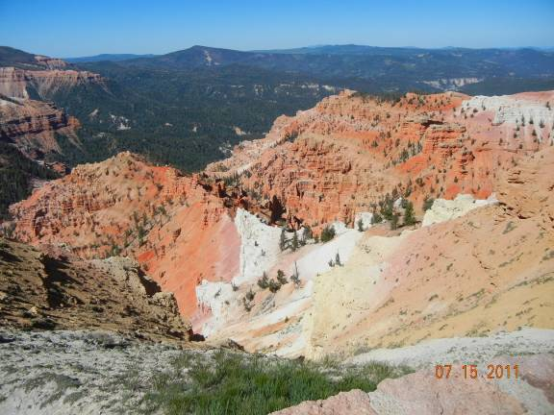
Leaving about 9AM we rode South out of Beaver on Interstate 15. We were backtracking about 35 miles to the town of Parowan Utah. We fueled at the T/A Truck Stop just off of Interstate 15. Riding through Parowan we observed lots of trees, manicured green lawns and well kept houses. This is typical of most small towns in Utah. We then headed East on Hwy 143 to Brian Head ski resort and then to Cedar Breaks National Monument. We took time to absorb the spectacular views from this alpine location. Riding on we passed Panguitch Lake and intersected Hwy 89. We stopped in Panguitch for a coffee break. We encountered major road construction as we rode north to Circleville Utah. Just north of Circleville we turned East on Hwy 62. Great views as we followed a pretty river to the Otter Creek Reservoir where Hwy 62 turns North. We stopped in the small Village of Koosharem Utah for a cool drink and a snack. Koosharem is the Indian name for Red Clover. Population of Koosharem is about 300. We had a great time at the small family run cafe. The children were on school vacation and helping mom out along with a few cousins. We intersected Hwy 24 a few miles from Koosharem and rode North to Hwy 119 and headed West over the mountain to the Best Western Inn at Richfield Utah. We walked to a nice restaurant for dinner and then retired for the night.
Miles today - 184

Day 4: Saturday July 16th - Richfield Utah to Lehi Utah
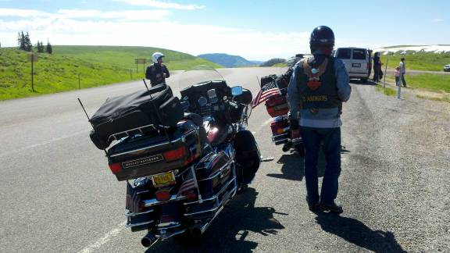
After a nice breakfast and a few photos with some tourists we headed North to Hwy 89 about a mile and then East on Hwy 70 for a few miles. We exited the freeway to re-join Hwy 89 heading North. We passed miles and miles of alfalfa fields with snow capped mountains as a backdrop. We stopped in Fairview Utah for a coffee break and to top off our fuel tanks. We headed East on Hwy 31 ascending into the mountains. We followed mountain streams and passed deep blue alpine lakes as we climbed to the summit. The views were breathtaking with patches of snow, tall pines and vivid green alpine meadows surrounding us. Leaving the East side of the mountains we stopped in Huntington Utah for some refreshments. Intersecting Hwy 10 we rode north to Price Utah where we stopped for lunch. We transitioned to Hwy 6 and then Hwy 89 and on to Lindon Utah and the local Harley Davidson dealer. Mike's injured leg had been giving him a lot of trouble so he purchased a pair of boots that were much more comfortable. We rode on to the Best Western Timpanogos Inn in Lehi Utah. We cleaned up and walked to a nearby mall where we purchased more medical supplies for Mike's leg. We then walked to a nice Mexican restaurant where we all enjoyed the large combination plate followed by fried ice cream. We did not want to walk back to our hotel and there were no Taxi's in this town so we negotiated with our server and he drove us back to the hotel. Lot's of laughs and fun. We cleaned and covered our bikes watched a movie and bedded down for the night.
Miles today - 240

Day 5: Sunday July 17th - Lehi Utah to Springville Utah
We have never had a sickness in all of the years that the 3 Amigos have been riding together. So this will be the first as I awoke early very sick. I was miserable and in no condition to ride a motorcycle. It was fortunate that we had planned to ride locally to Park City Utah and the local mountains on this day. Our next hotel was only 35 miles South of Lehi. We requested a late check-out and I called the other hotel to make sure that our room would be ready when we arrived. Mike and Robert went to breakfast and then watched movies. Our room had separate sleeping areas so this worked well as I slept. We left the hotel about 1PM and arrived at the Best Western Mountain View Inn in Springville Utah about 1:45PM. Traffic was very light since it was Sunday. I had not eaten anything and was dehydrated so Rob brought me some gator aid. I was able to keep it down so I was on the slow road to recovery. I slept away the day. Mike and Rob went to dinner and brought me chicken soup. Great medicine. We retired for the night looking forward to a better day tomorrow.
Miles today - 23

Day 6: Monday July 18th - Springville Utah to Torrey Utah
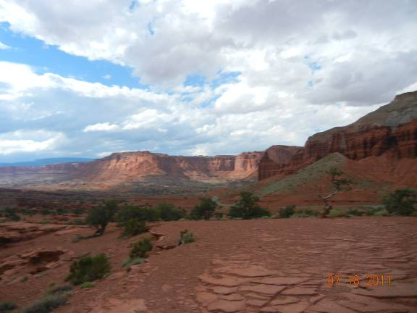
I felt much better this morning and was ready to ride. We were surrounded by puffy white clouds, a few thunder cells and patchy blue sky as we departed Springville. We backtracked our previous ride taking Hwy 6 to Price Utah then Hwy 10 to Huntington where we stopped for fuel. Continuing on Hwy 10 we passed under Interstate 70 and began our ride over the mountains on Hwy 72. Large black thunder cells were in the distance clinging to the mountain tops. We only experienced a few drops of rain as we ascended the mountain and rode through field after field of wild flowers. We arrived at the Best Western Capitol Reef about noon and checked into our room. This would be the only night that we would require a roll-away bed as we were able to reserve a family suite on previous nights and each had our own real bed. The view from the hotel and the highway are marvelous. We walked across the highway and had lunch at the Spaghetti Western Cafe' then headed to Capitol Reef National Park. We entered the park and began to ride the 20 mile, round trip, scenic road through the park. We immediately encountered road construction with lots of gravel. This road is very scenic but a bit harrowing on 800 pound motorcycles riding on and through gravel. We completed the trip and stopped a the visitors center where we took time to learn the history and significance of Capitol Reef National Park and the village of Fruita. We returned to our hotel about 5PM and enjoyed the pool, hot tub and visiting with two families from France that were touring Southern Utah. We had a magnificent dinner at the Rim Rock Restaurant across the highway. The changing shadows on the hills around us as well as the sunset provided us with a beautiful evening. We cleaned and secured our motorcycles, and retired for the night.
Miles today - 224

Day 7: Tuesday July 19th - Torrey Utah to Kanab Utah

Up a little later this morning we all slept good and felt good. Even the roll-away bed provided a good nights sleep. We checked out of our hotel and rode to the small town of Torrey Utah for breakfast. We found a quaint little bakery and enjoyed a light breakfast on the outside patio. It was a gorgeous morning as we were to ride one of the prettiest roads in America. We fueled our bikes at the intersection of Hwy's 24 and 12. We rode South on Hwy 12 gaining elevation a few miles from Torrey. We entered the Dixie National Forest and rode through miles and miles of Pine trees and groves of Aspens. When we reached the alpine elevations we found many fields of wild flowers. As we descended the mountain the scenery changed and we entered the lovely village of Boulder Utah. This is a beautiful lush valley surrounded on one side with typical Utah rock formations and on the other by the Dixie National Forest. Leaving Boulder we

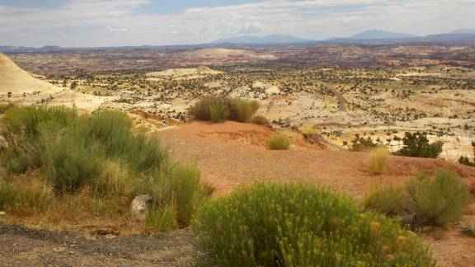
climbed out of the valley and began our ride across the 'Devils Backbone'. This is a ridge road with deep tree lined gorges on both sides. This is one of the prettiest areas that we have enjoyed in all our years of riding. It is very hard to find the words to offer a realistic description of this area. We fueled in Escalante Utah and found that our favorite cafe' has been closed. On to Bryce City Utah where we stopped for lunch. We had a brief thunder shower as we enjoyed our meal. After wiping off our bikes we continued through green valleys and magnificent canyons to the Best Western Red Hills Inn at Kanab Utah. We had reserved a large room in a separate building at this hotel. The place was fully booked as three bus loads of Italian tourists descended on the place. We took a dip in the pool and cleaned and covered our bikes as large thunder cells were overhead. Rob & I walked a few blocks and found the local ice cream parlor and enjoyed talking with the locals about living in Kanab. We returned to the hotel, enjoyed another great sunset and retired for the night.
Miles today - 184

Day 8: Wednesday July 20th - Kanab Utah to Primm Nevada and Gallup New Mexico
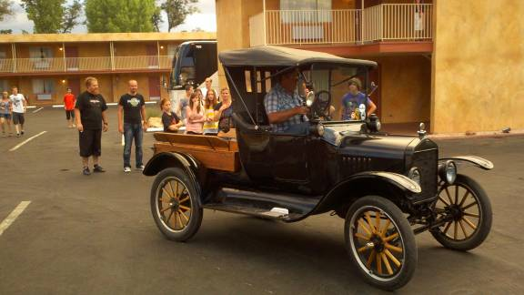
This would be the official end to the 2011 '3 Amigos Ride' as Mike headed home to Gallup New Mexico and Rob and I departed for Primm Nevada. Rob and I rode with Mike to the South end of town on Hwy 89. Mike then headed East on Hwy 89 and we headed South to Fredonia Arizona then West on Hwy 389 back into Utah then West on Hwy 59 to Hurricane Utah and Hwy 9 to Interstate 15. It was heating up so we stopped in Mesquite Nevada for fuel and put on our hydration vests. It was hot as we approached Las Vegas so we stopped at the 4 Queens Casino and parked in the covered garage. We had a nice lunch and walked a bit on Fremont street which is covered and cooled. Back on Interstate 15 we arrived at Buffalo Bill's Hotel and Casino in Primm Nevada about 4PM and checked into our room. When I made my reservations they included coupons for the attractions at the casino. Rob and I played the slots for awhile then decided to take advantage

of the rides. We rode the Desperado roller coaster, the Turbo Drop of 170 feet (twice), Adventure Canyon Log Flume and all three of the Vault A 3D Experience which is the very first 3D high def digital projection motion ride in the United States. Rob also rode the Maxflight Cyber Coaster. We calculated that we received $$ in attractions for the $26.00 price of our room. Not bad. It was so fun to set our age aside and just enjoy the rides. We had dinner and then retired to our very nice room for the night. Mike called and let us know that he arrived home about 3:30PM.
Miles today - Mike 329 - Joe & Rob 241

Day 9: Thursday July 21st - Primm Nevada to Homes
Rob and I arose at 4:30AM for our ride home. We had coffee and a pancake at the casino and then headed out at first light. The ride on Interstate 15 was cool and traffic was very light. We stopped at Peggy Sue's 50 Diner just before Barstow California for breakfast. This diner is right out of the 1950's with lots of memorabilia. We then rode on to Victorville California and stopped for fuel. Riding over Cajon Pass we parted company as Robert continued on Interstate 15 to Escondido and I transitioned to the 210 Freeway for my ride to Torrance.
Miles today - 260

Epilogue: The 3 Amigos (Brothers) - Mike 70, Joe 68 and Robert 65 had another memorable ride. We visited with tourists from France, Germany, Switzerland, Israel and Holland as well as meeting the folks that live in the small towns and villages of our great country. We have found that Utah offers a very diverse geography and beautiful scenery. Our Harley Davidson motorcycles performed flawlessly and presented no problems during our trip. We rode this trip slow and easy enjoying the ride and stopping often to absorb the beautiful views. Our motorcycles achieved 50+ miles per gallon most of the trip.
We hope that you have enjoyed riding along with us. We look forward to riding together again in 2012.

If you would like to view photo's of our ride please copy & paste

http://3amigosride2011.shutterfly.com/pictures/93

into your browser, select 'slideshow' then select 'full screen' you can then 'pause' the show at any time if you wish.

